Computer Vision

Problem: input is usually very large => use convolution to solve this problem

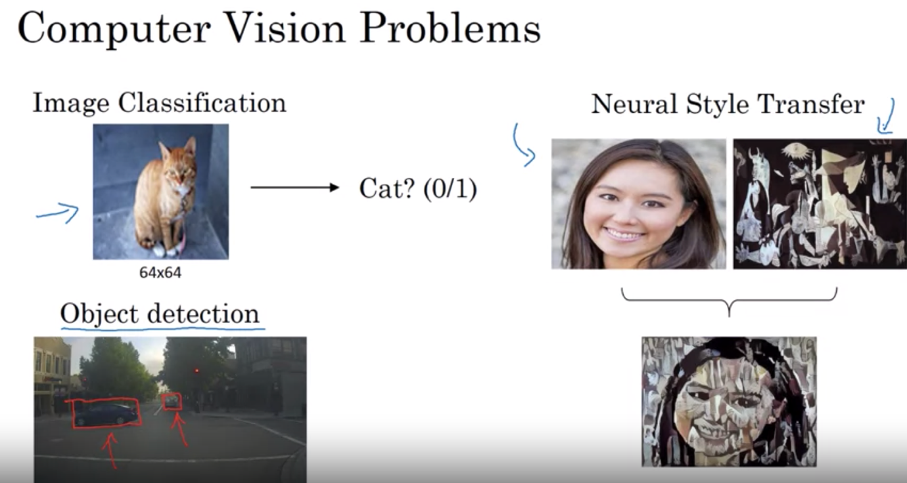

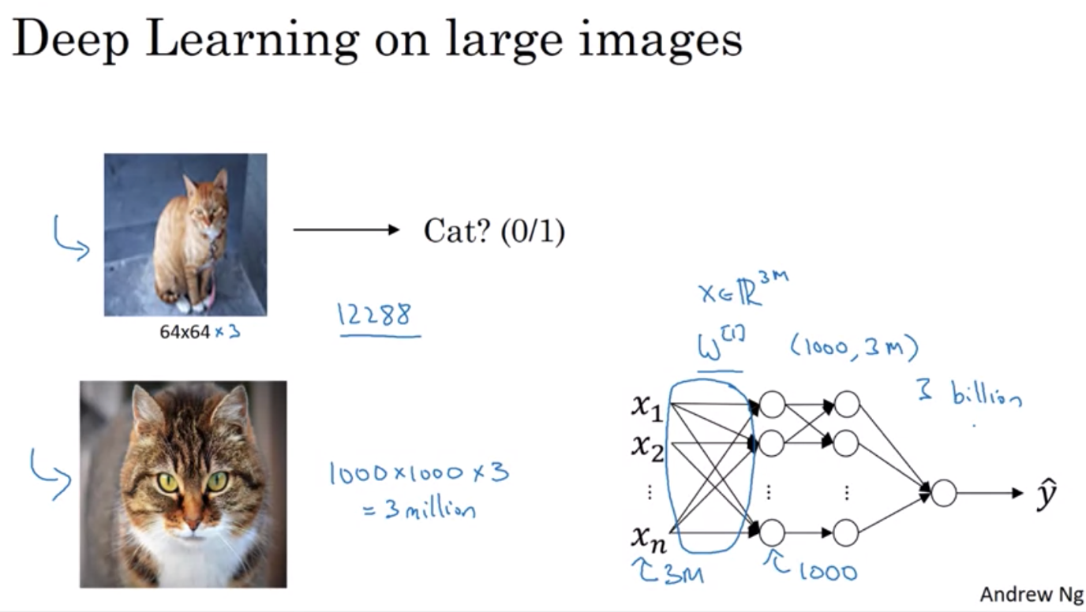

Week 1 – Foundations of CNN

Edge Detection Example: see how convolution operation works

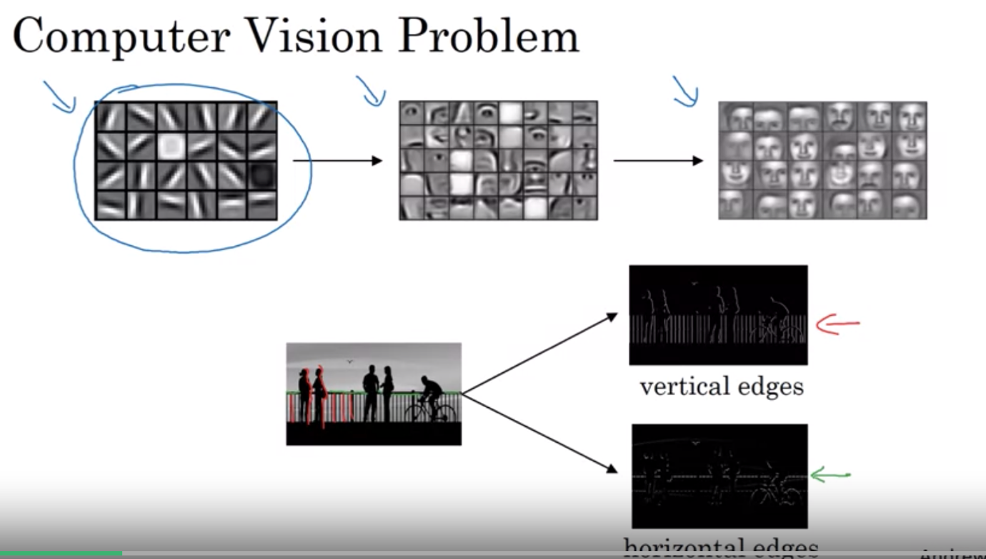

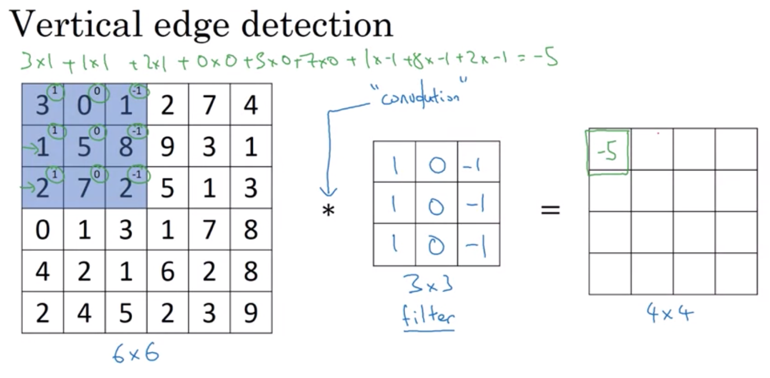

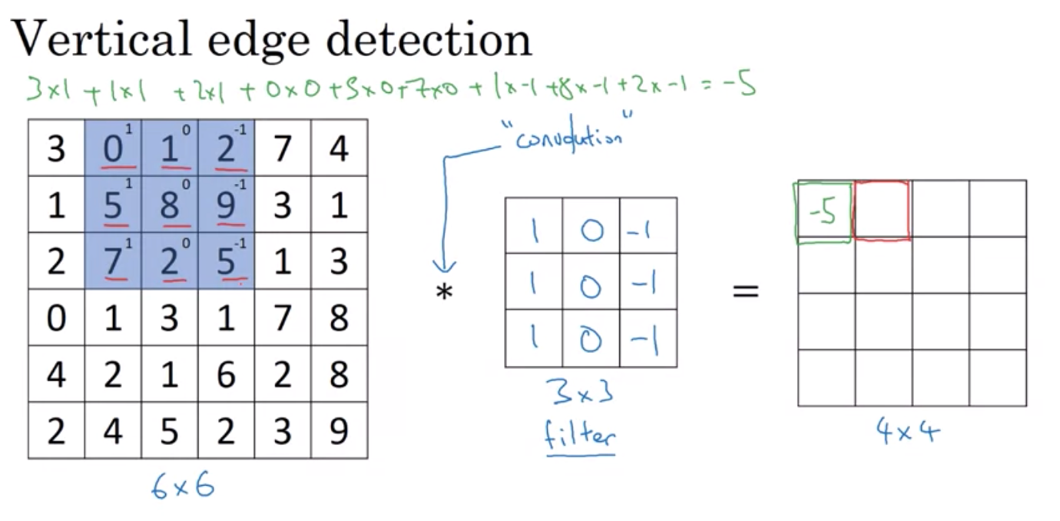

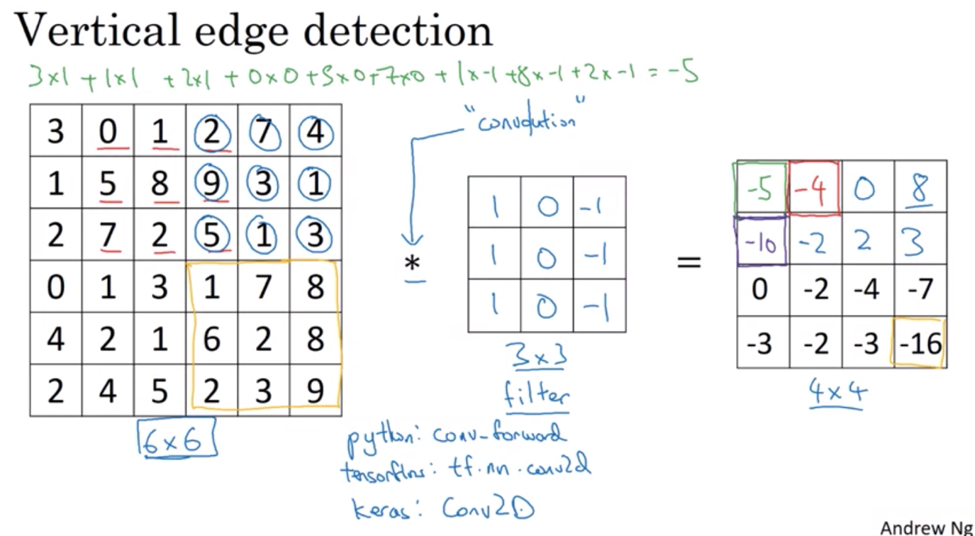

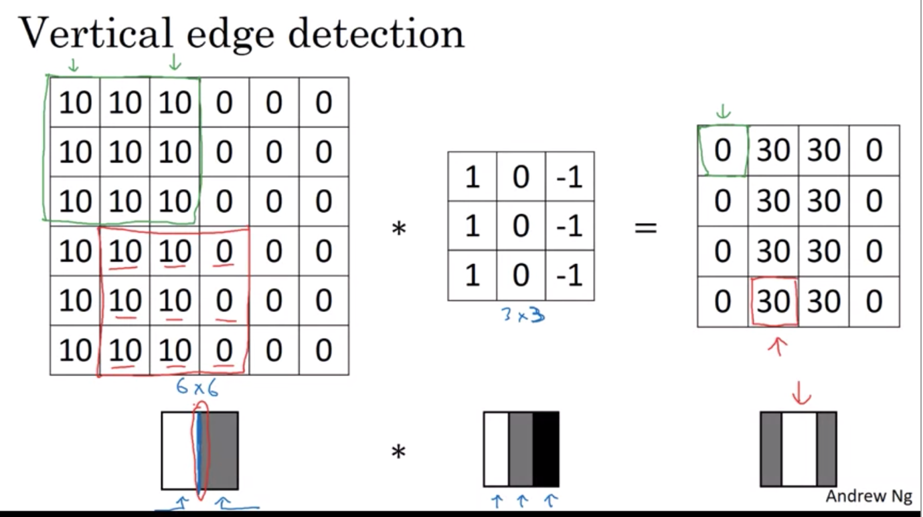

Vertical edge = bright pixels on the left, dark pixels on the right

* Convolution defines a convenient way to see if there is a vertical edge

How an algorithm learn to detect edge:

* Different types of filter to detect different types of edges
* Different numbers in the filter also to detect edges better => might be able to treat it as a matrix of weights/parameters which we can learn the value of through back propagation to choose the best weight that can produce a good edge detector

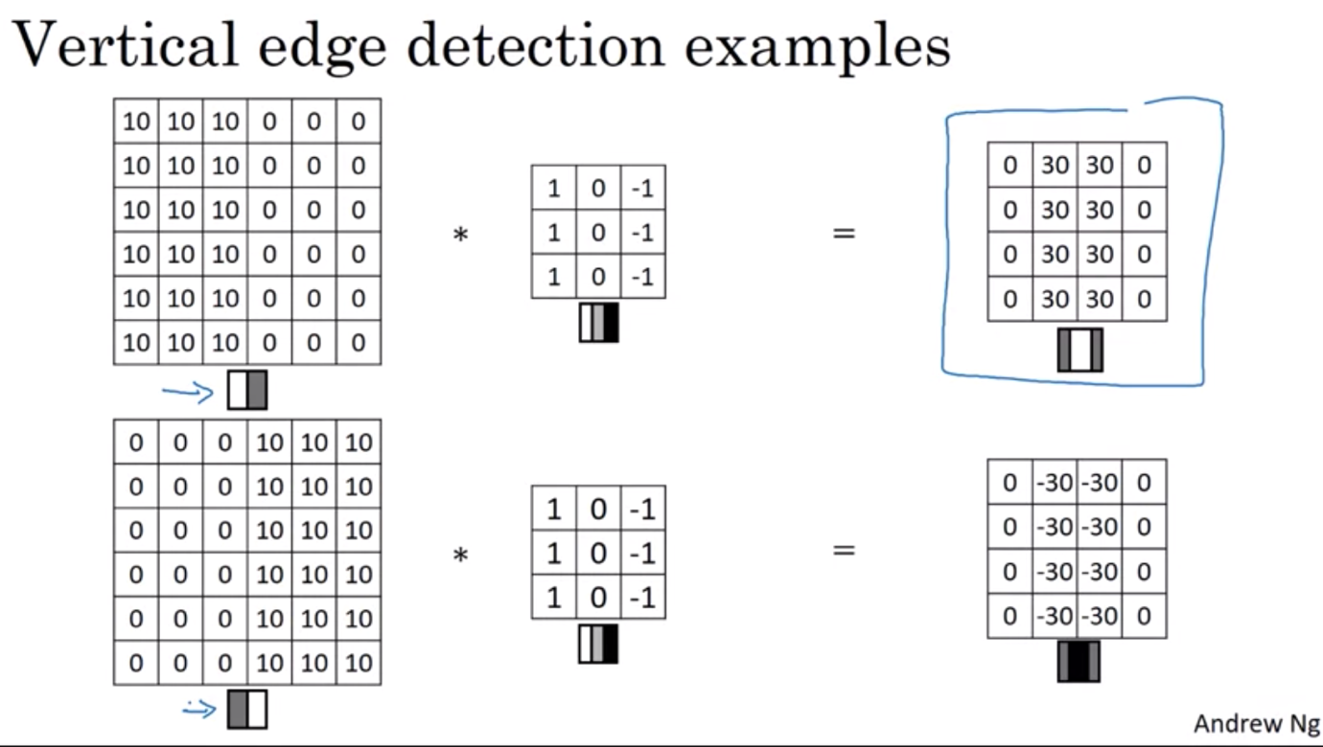

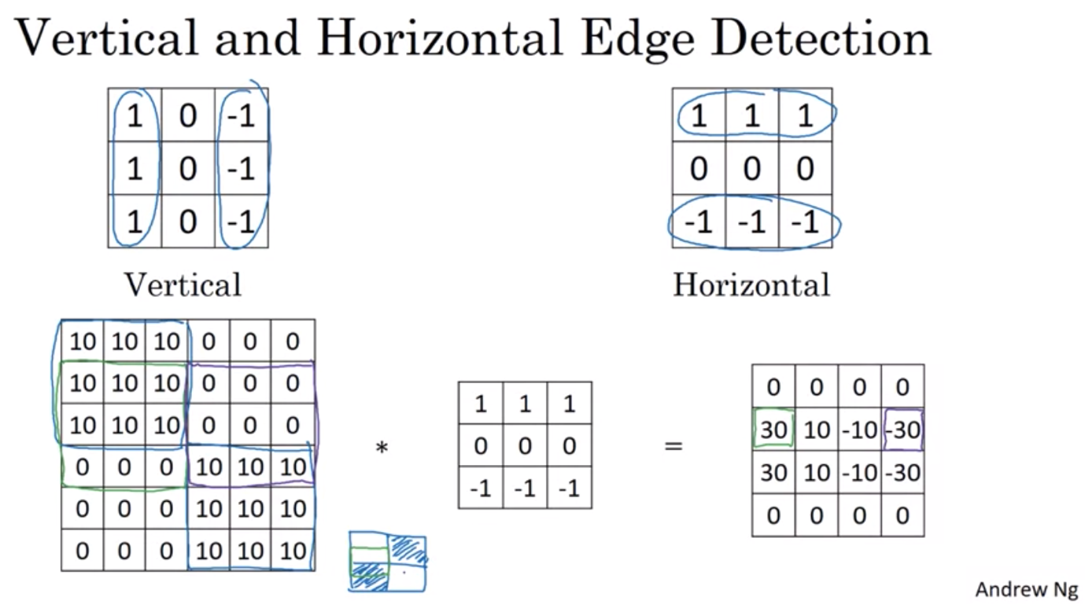

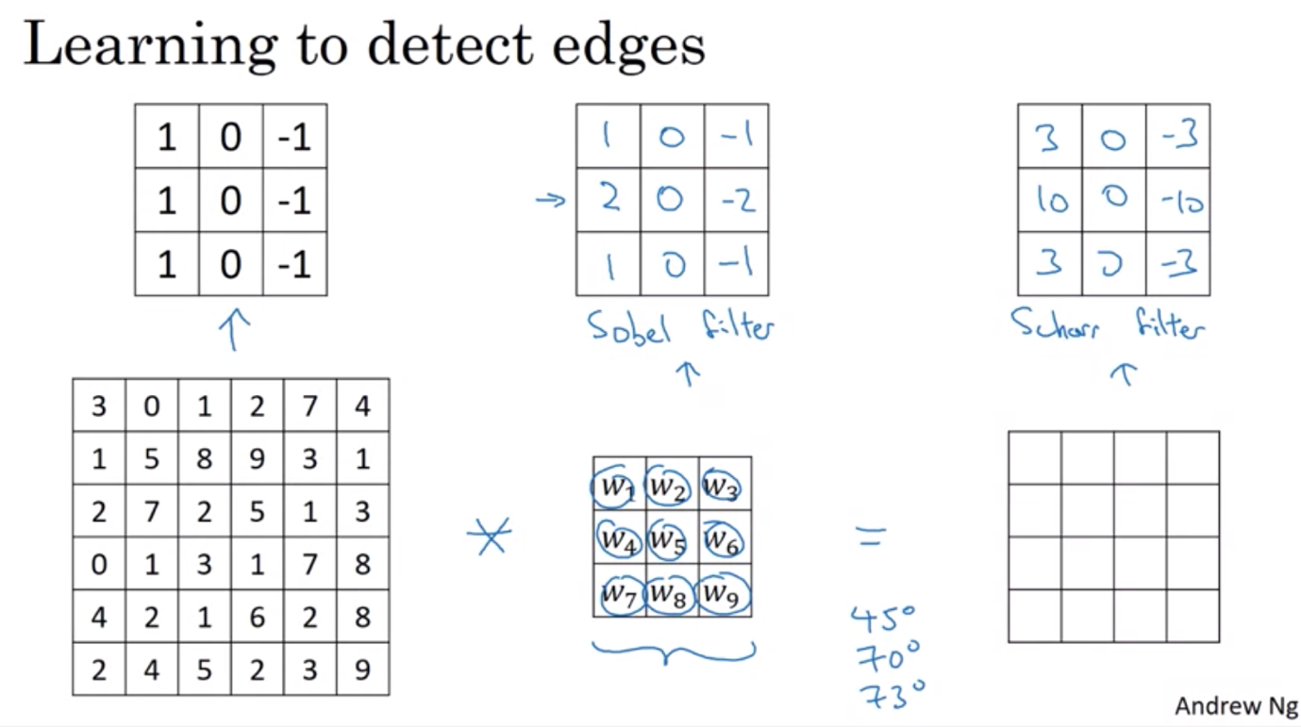

Padding:

Downside of convolution: by convention, filter dimension is always odd

* Everytime you apply convolution, you image shrinks, you can only do this a few time before the image becomes really small (1x1)
* Pixel at the edge of the picture is used only once whereas the ones in the middle are used multiple times => information on the edge are thrown away
* To solve both problems: use padding – pad 1 additional layer of pixels surrounding the image
* Preserve the original image size (6x6 => padding => 8x8 => convolution => 6x6)
* The pixel on the border is used multiple times
* Can have more than padding layer > 1

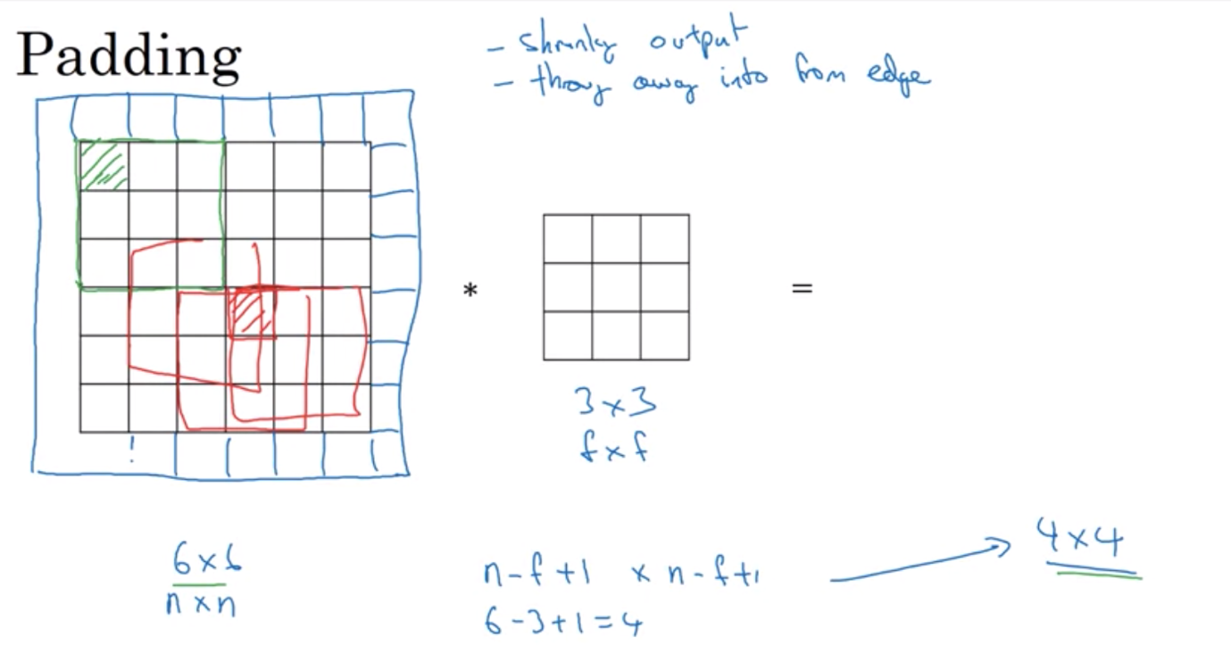

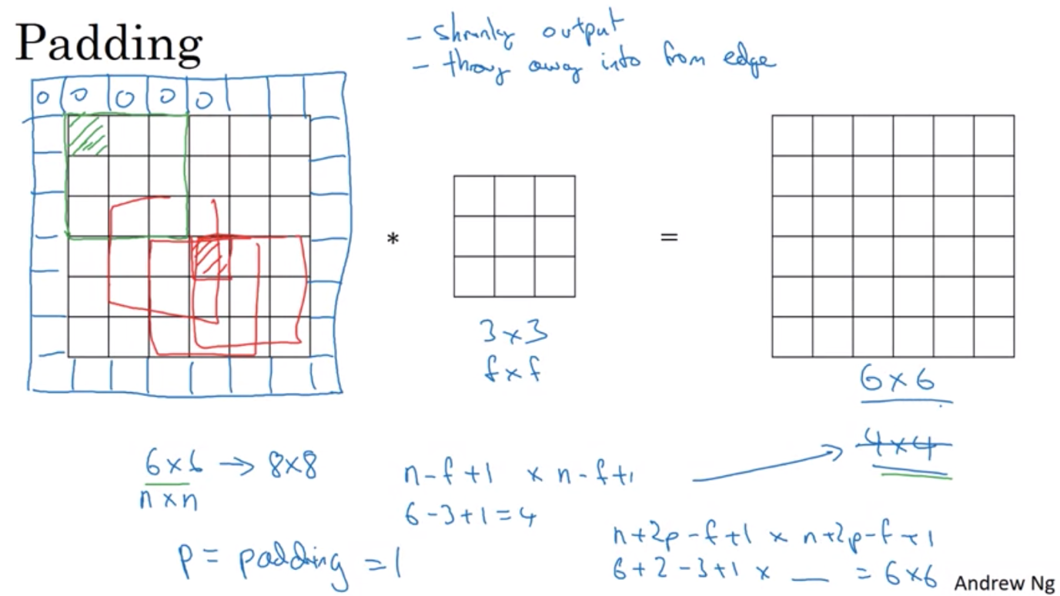

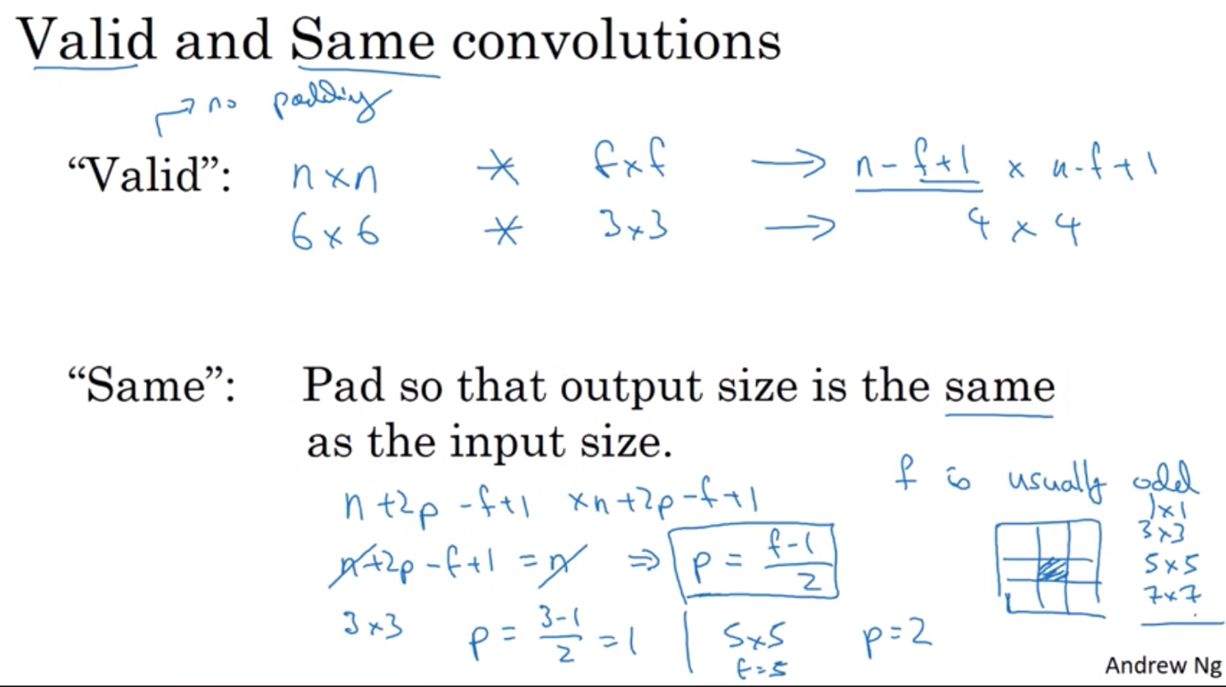

STRIDED CONVOLUTION

Jump 2 steps instead of 1

If division is float => round down to get the correct size of the output

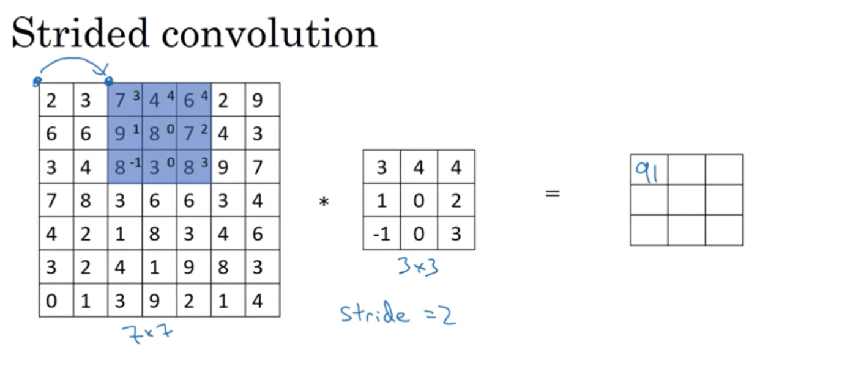

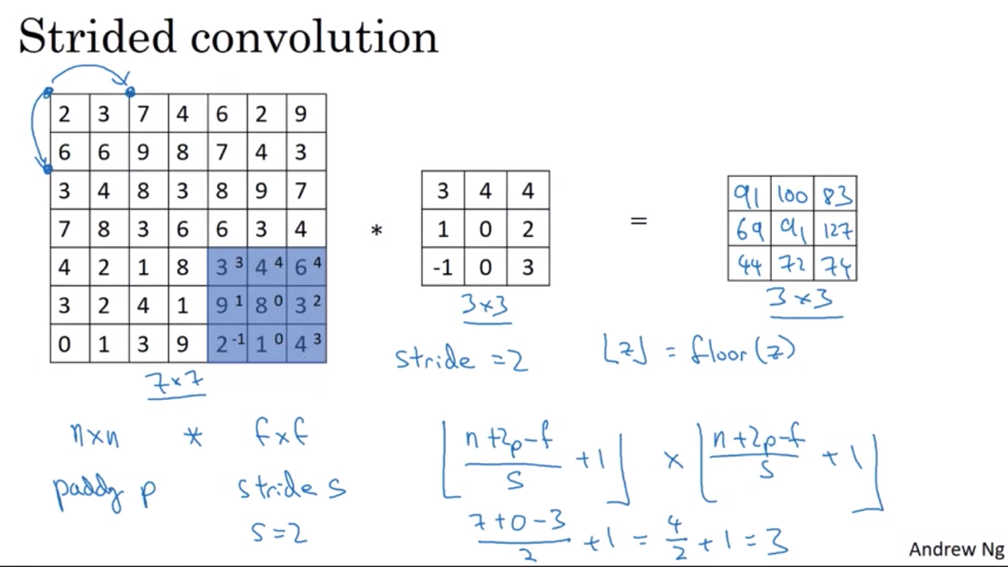

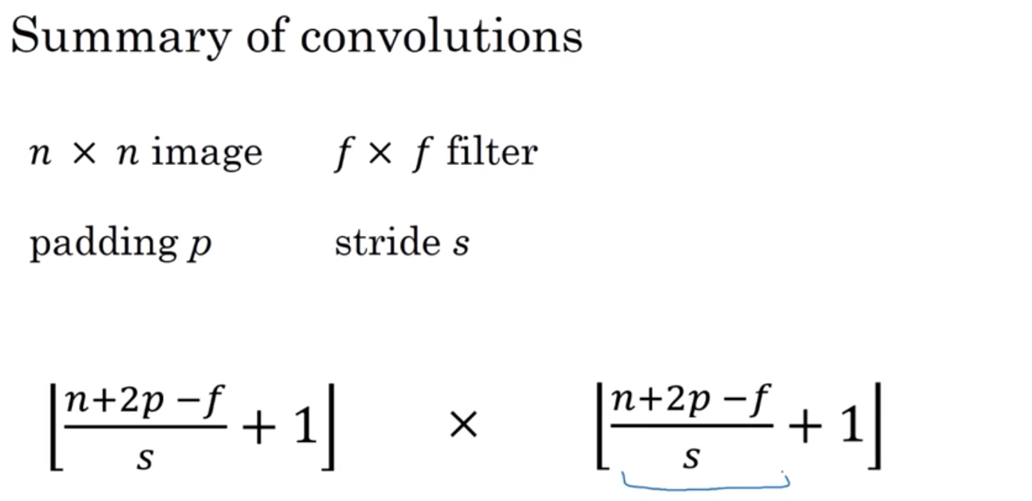

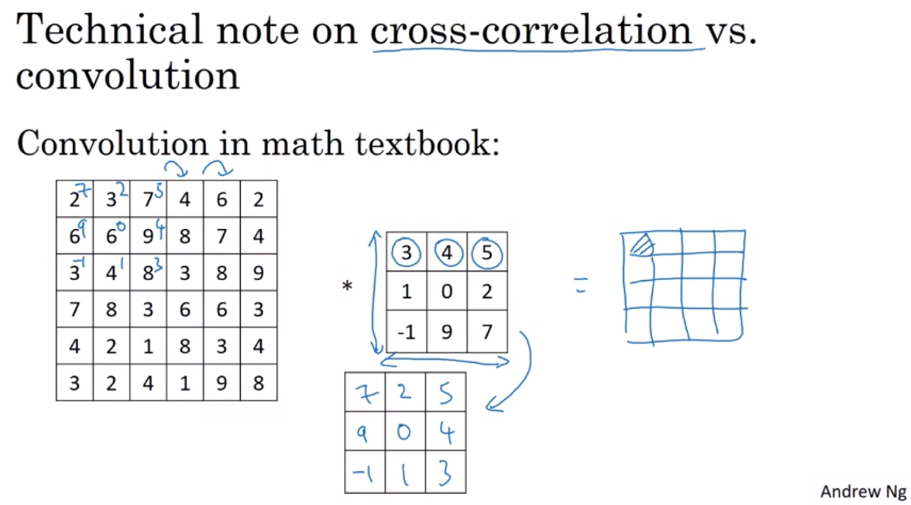

CONVOLUTION OVER VOLUMES

By the choice of parameters, we can get feature detection on different channels or regardless of channels

For multiple filters => combine the output at the end

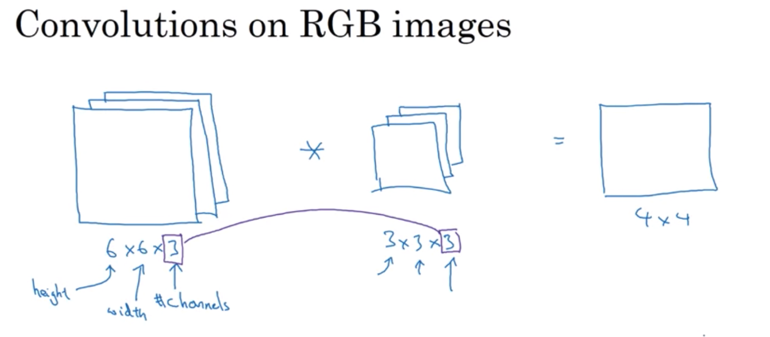

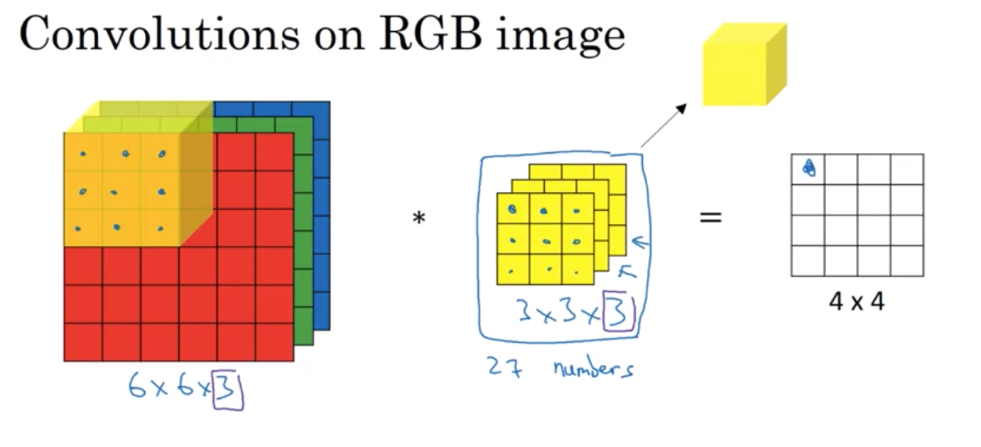

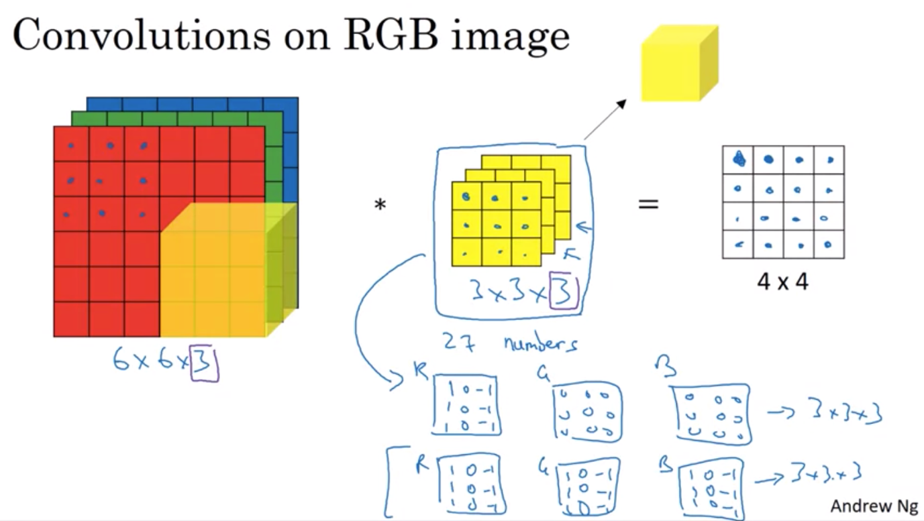

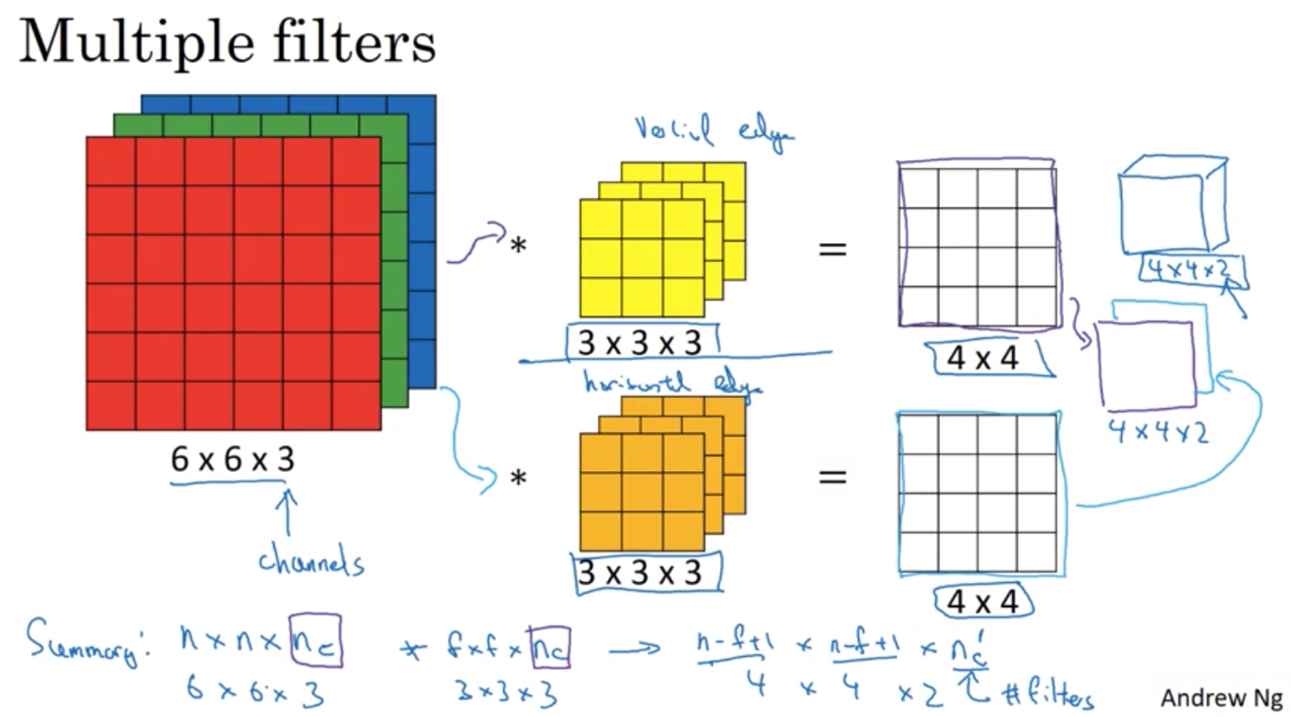

ONE LAYER OF CONVOLUTIONAL NEURAL NETWORK

Add a bias to the output of convolution

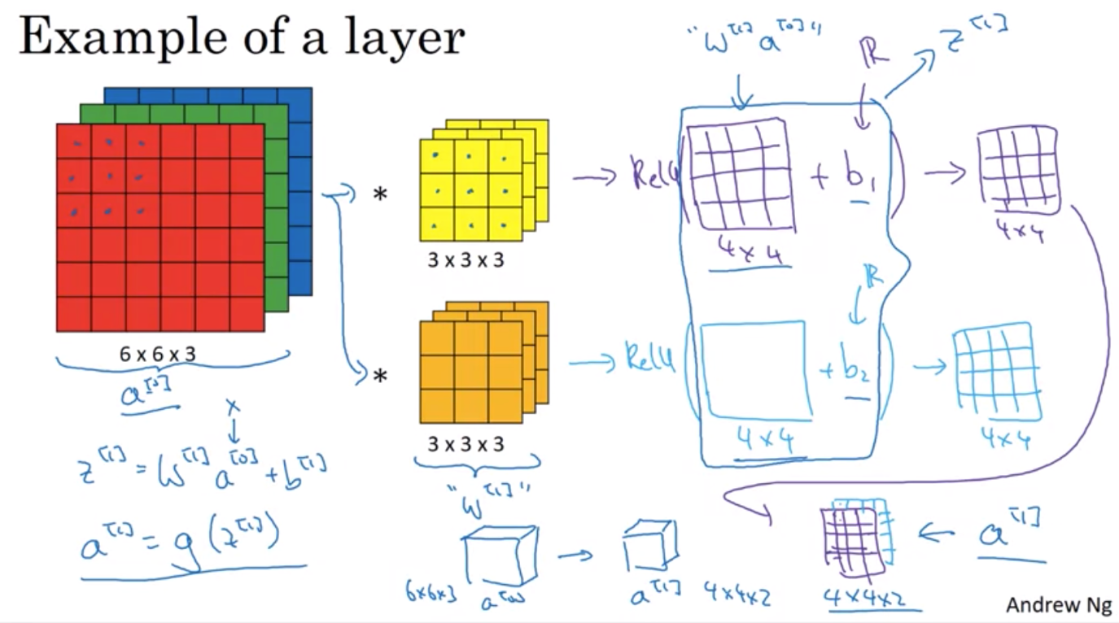

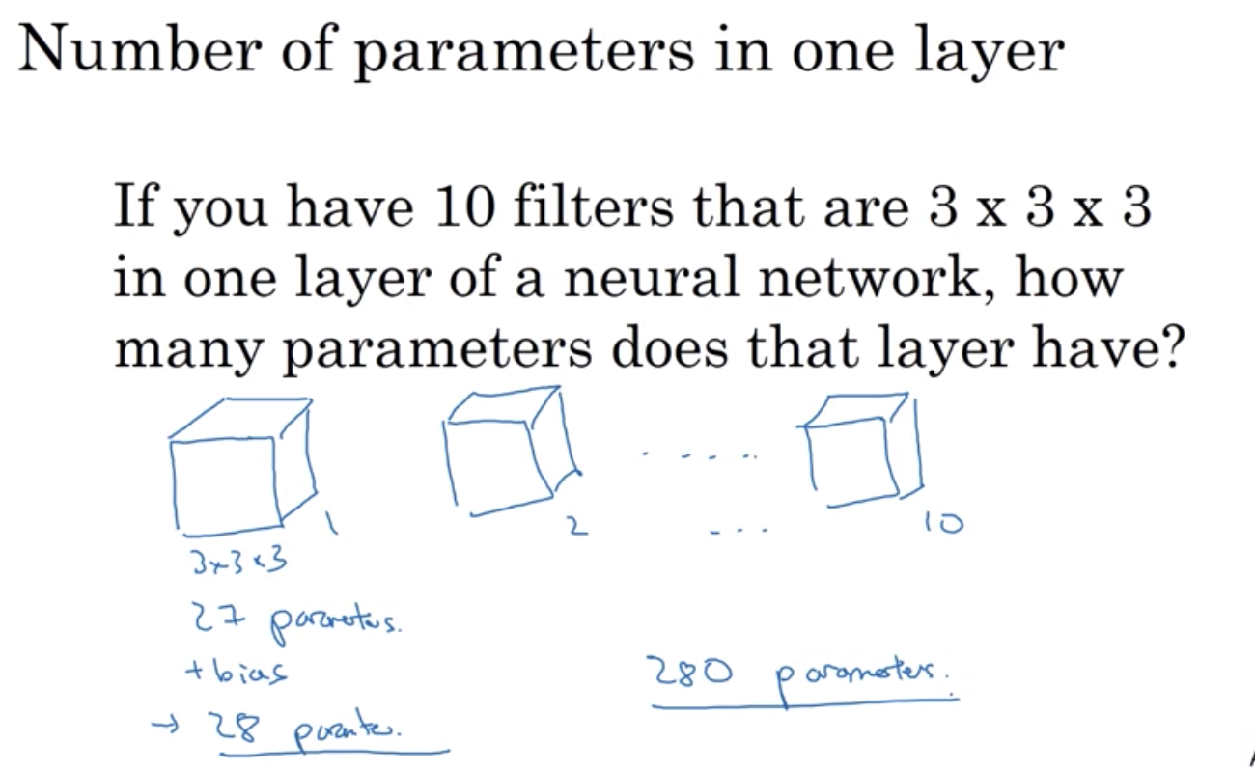

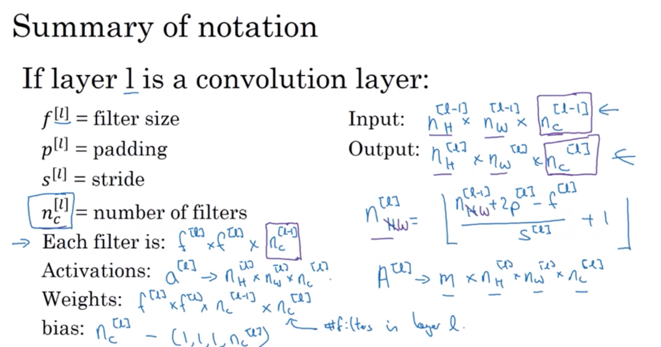

SIMPLE CONVOLUTIONAL NEURAL NETWORK

Last layer of the ConvNet is fed into a logistic regression/softmax

* Most of the work go into selecting hyperparameters (what’s the size, padding, stride
* Start out with the full size => trend down to smaller and smaller size whereas the number of channels (features) increase

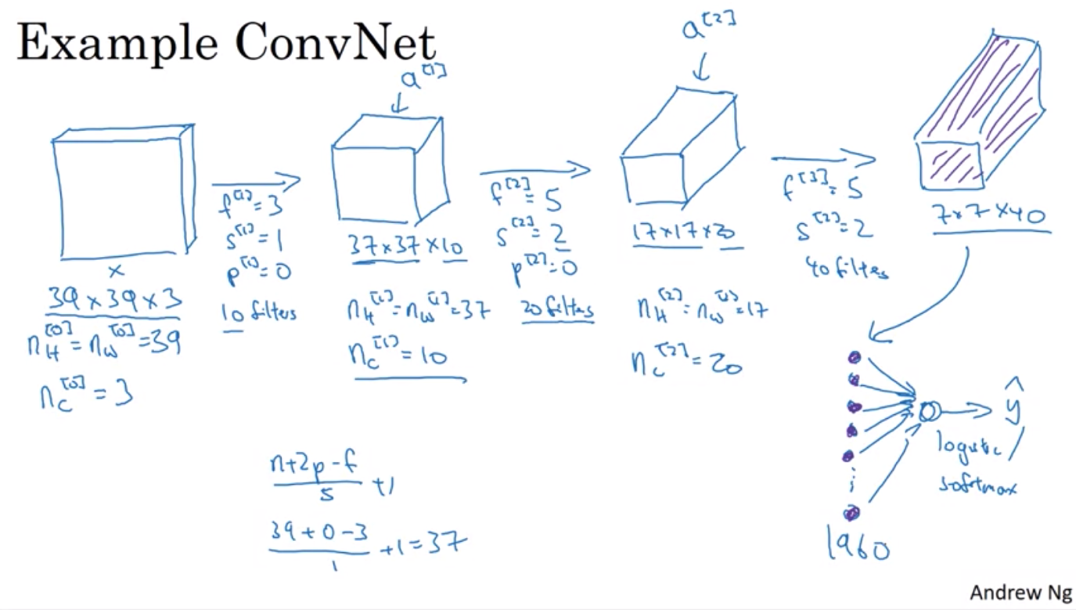

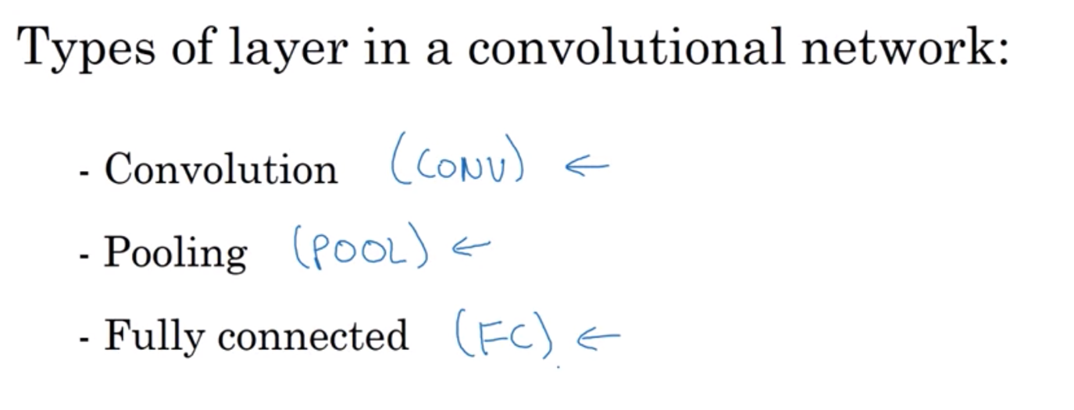

POOLING LAYER

Other than convolution layer, ConvNet also uses pooling layer to reduce the size of the representation to speed up the computation as well as some of the features that detect a bit more robust

* Take the max of the segmented region
* If we think of this 4x4 as some kind of features => max of a region helps to detect certain features in that region => features detected anymore in the original size is then preserved in the maxpooling output
* Has a set of parameters (how big the size of the region, stride – step size) but nothing to learn => once you fix f and s, gradient descent doesn’t change anything
* If more than one channel => computation is done separately on each channel
* Padding is usually not applied

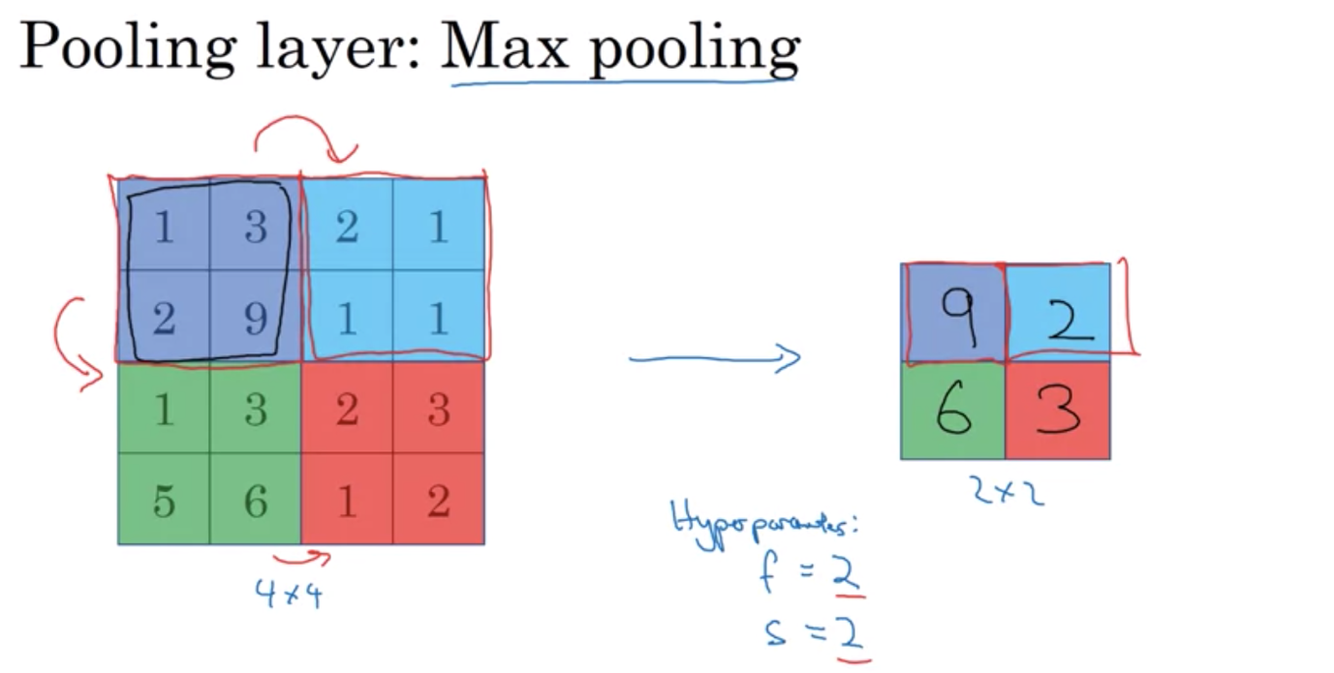

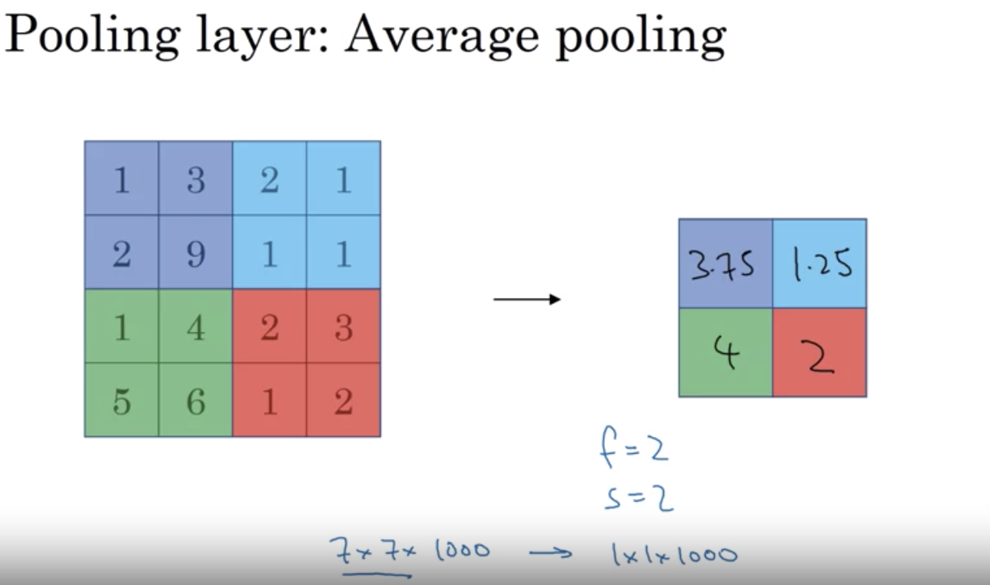

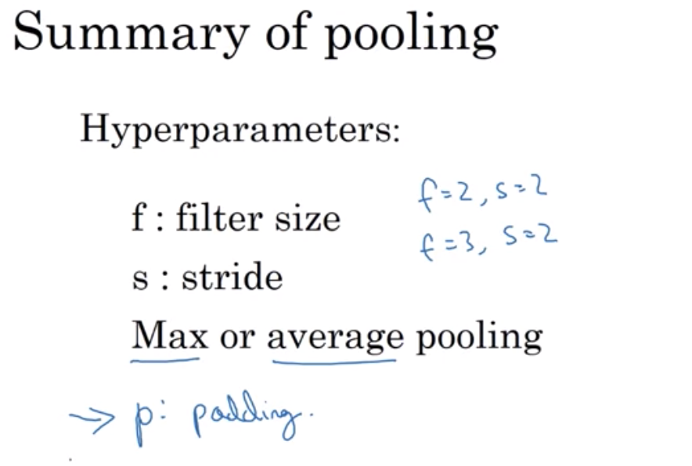

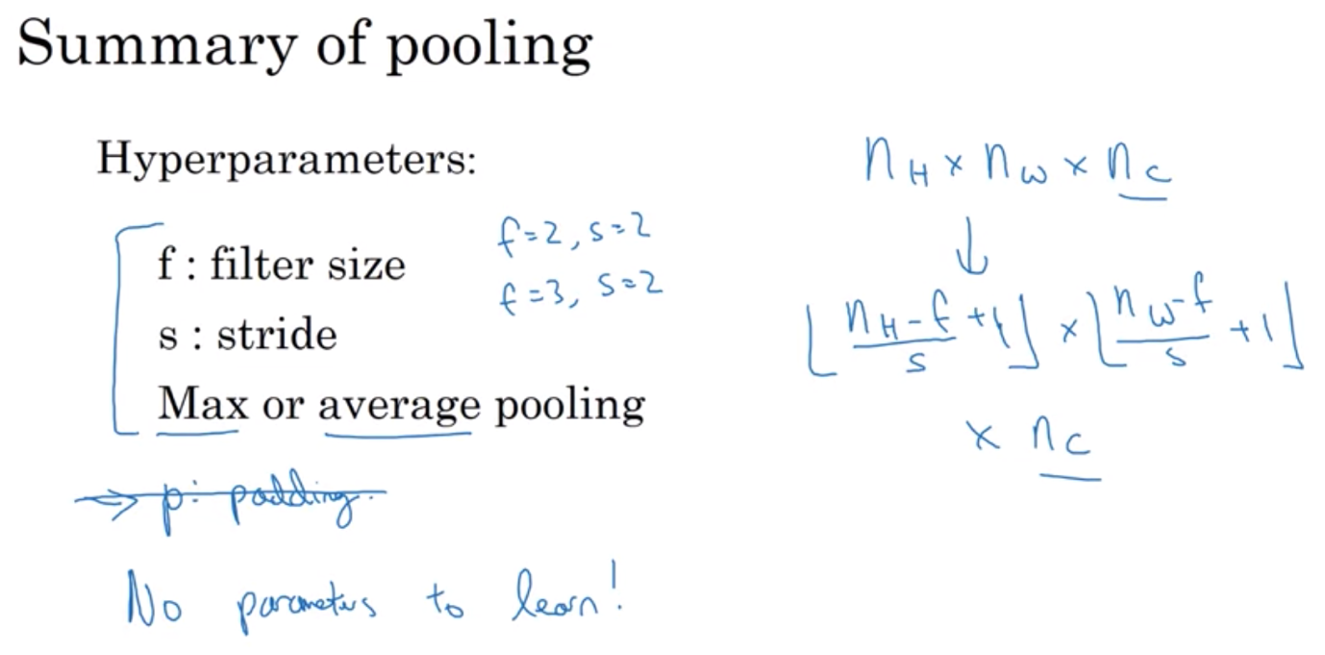

CNN Example

Conventions: convolution layer, followed by a pooling layer, followed, by a convolution, followed by pooling, followed by a few fully connected layer => softmax

* Conv layer usually has few parameters
* Most parameters are in the fully connected layer
* Activation size decreases as you go deeper into the neural network. However, if it drops too quickly => not great for performance as well

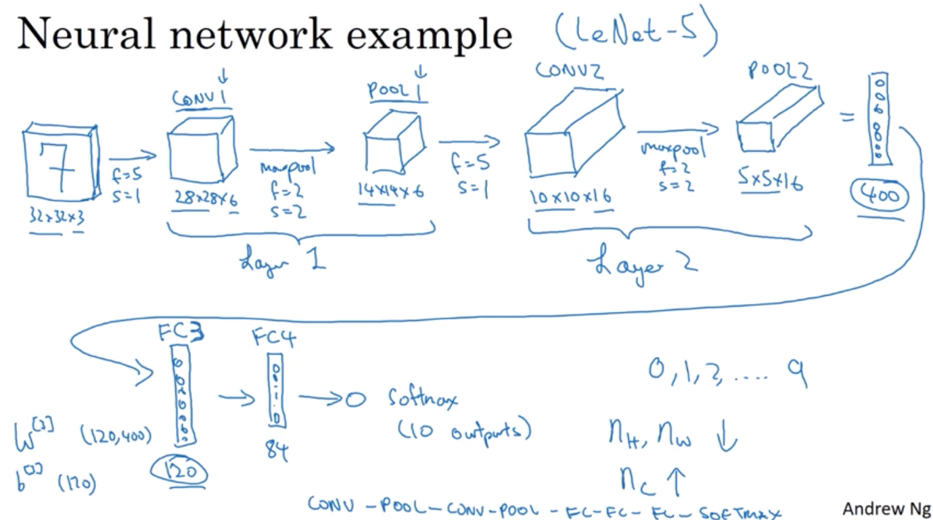

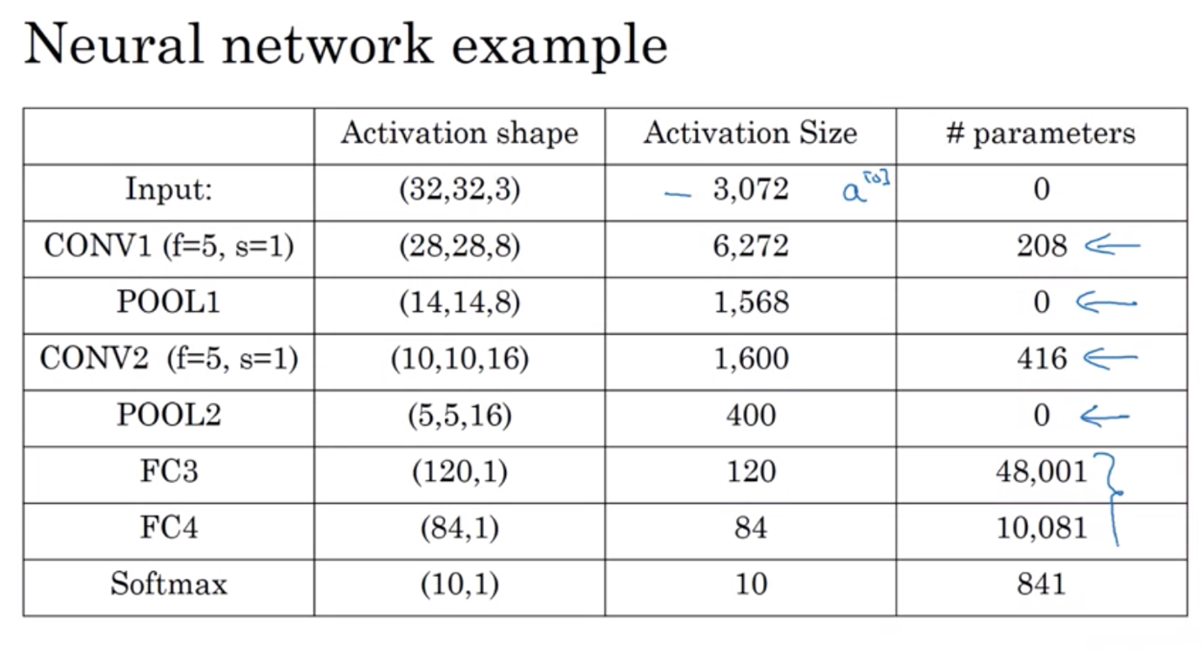

Why Convolution?

Advantages of using convolutions rather than just fully connected layers:

* Parameter sharing: same parameters is used again and again with different region of an image whereas for FCL, huge number of parameters to compute
* Sparsity of connections
* Neural networks has fewer parameters => allowed to be trained with less dataset => less prone to overfitting
* Also good at capturing translation invariance: pic of a cat shifted a bit is still a cat => convo can learn that and output that same pic still has same features and structures => should be labelled same as before => applying same filter helps the neural networks to capture this desired property of translation invariance

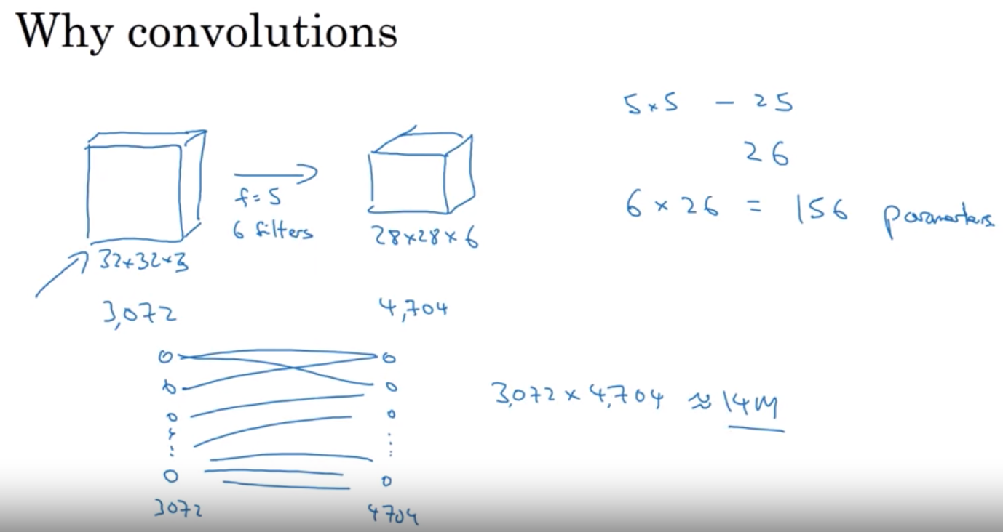

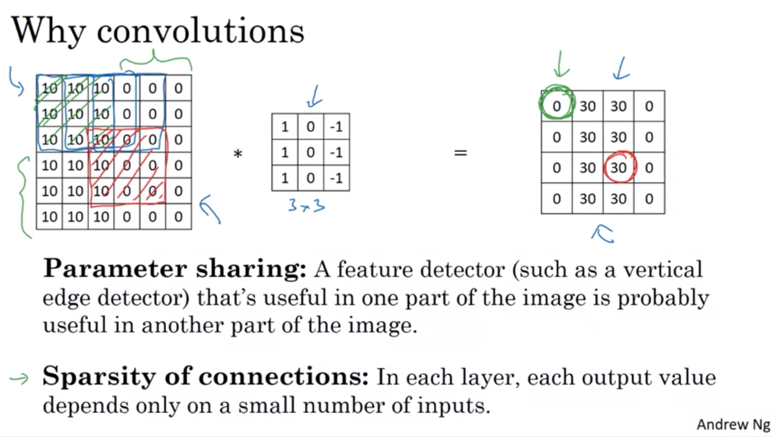

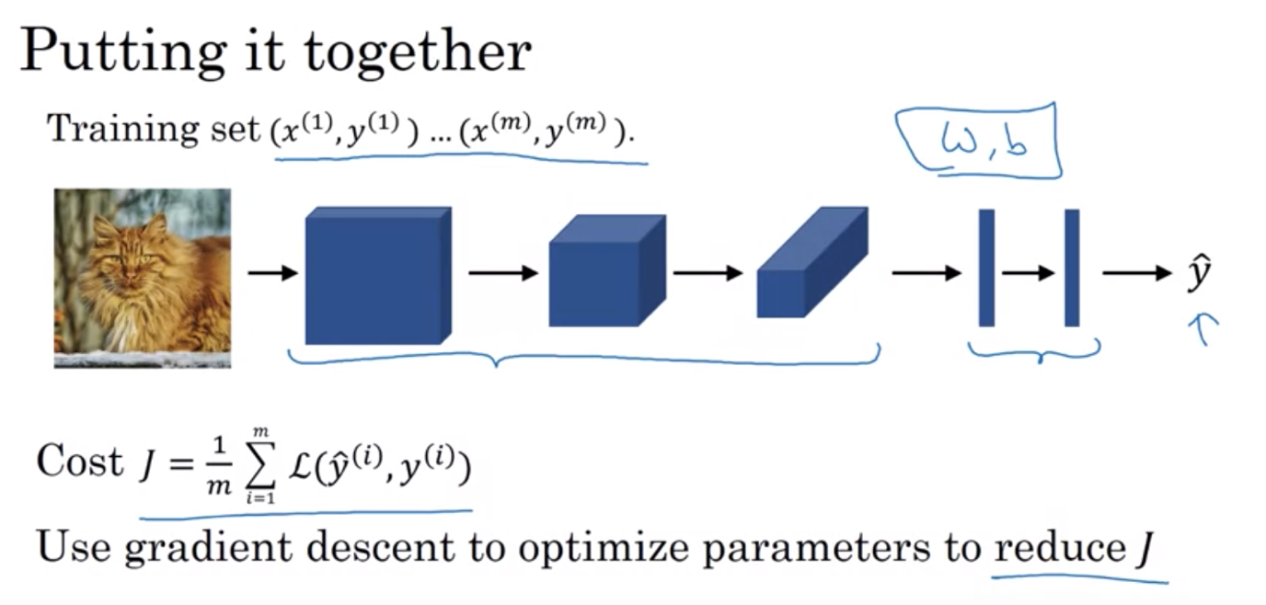

WEEK 2 – DEEP CONVOLUTIONAL MODELS: CASE STUDIES

See case studies to know how these building blocks come together

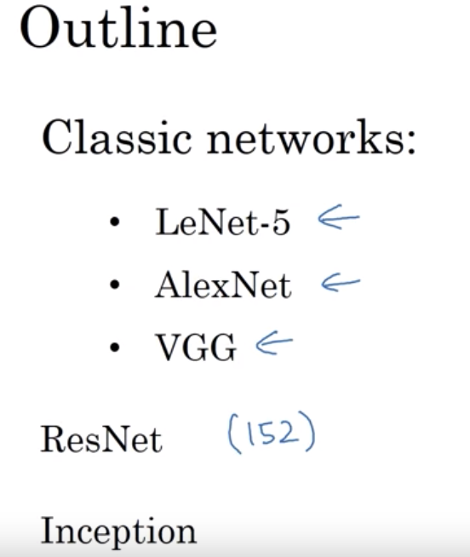

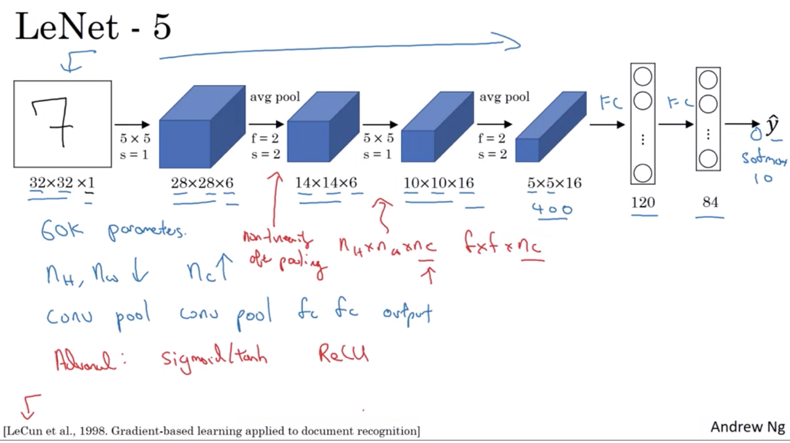

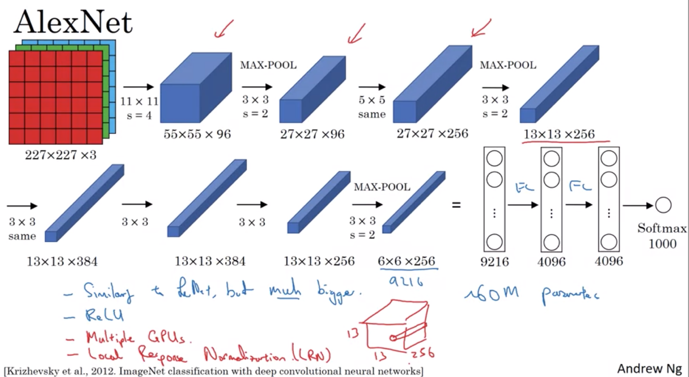

VGG – Simplify neural network architecture

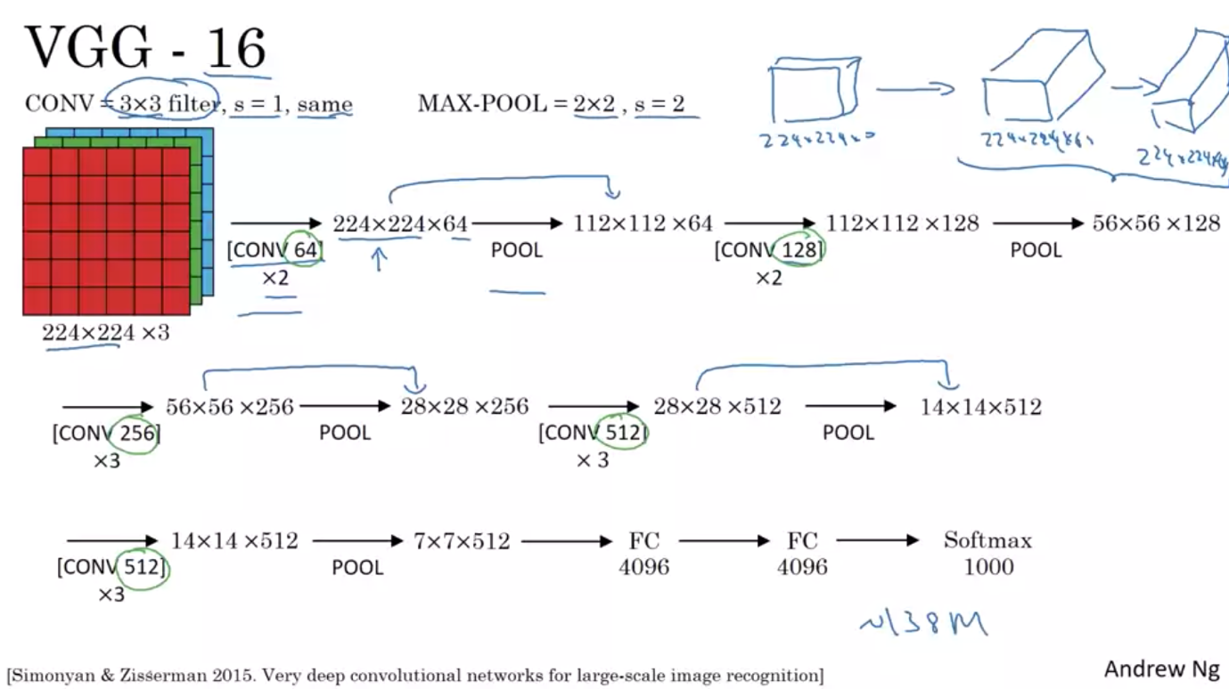

ResNet

Very deep neural networks are hard to train because of vanishing/exploding gradient problem

* Skip connection: use activation in one layer and feed it to another layer even deeper in the neural network
* ResNet: able to train very deep neural network without loss of performance – taking many residual blocks and stack them together to form a deep neural network
* With plain network, in reality, after training for certain period of time, the error rises up. But by training with residual block, ResNet is able to train very deep model without losing that.

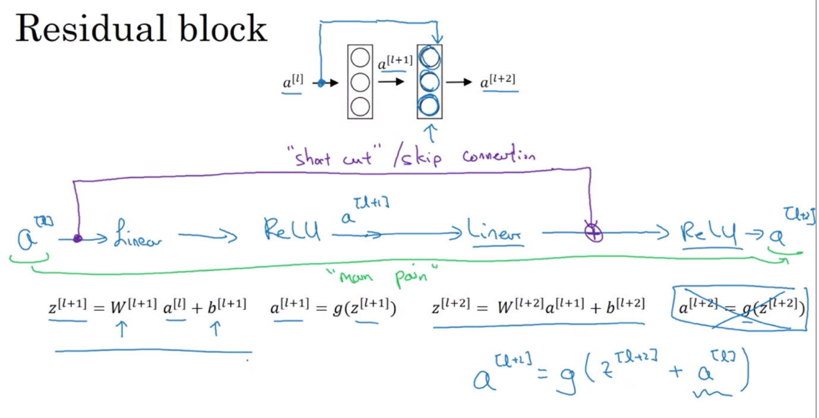

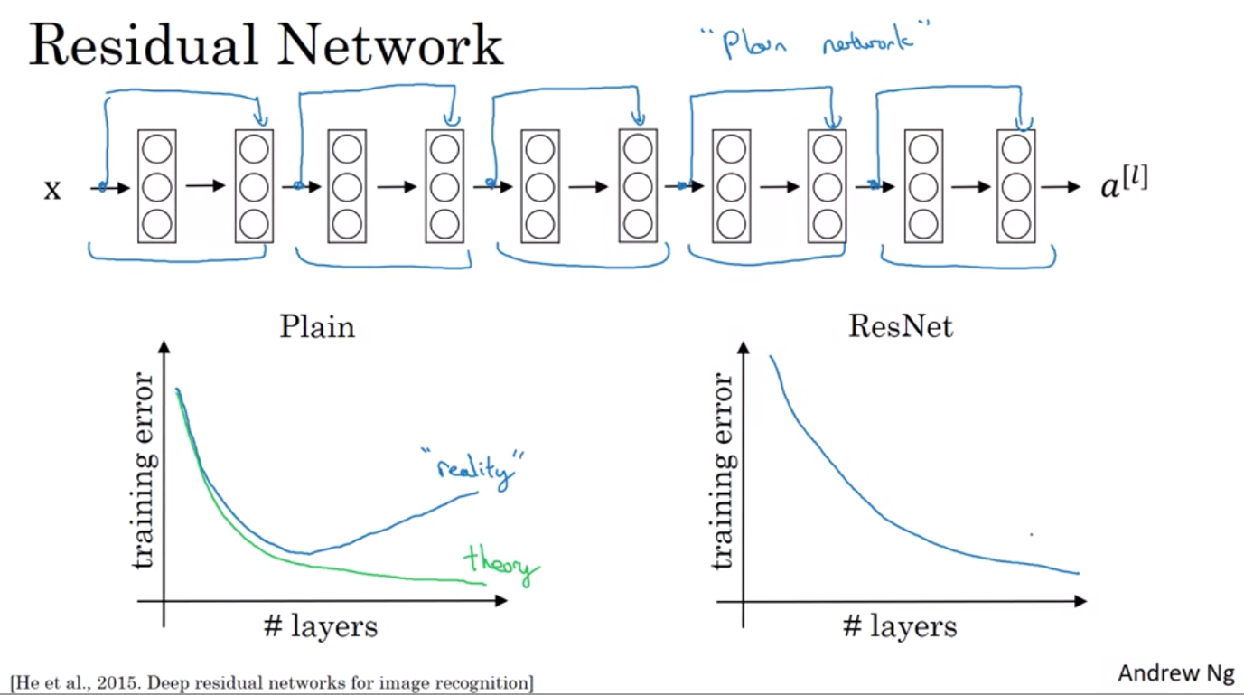

Why ResNet works?

It’s easier for the neural net in ResNet to learn the identity function

* One thing to keep in mind is Z(l+2) and a(l) should have same dimensions => a(l+2) and a(l) should have same dimensions. That’s why we see a lot of same convolution so input layers having same dimensions as output layers
* If the layers do not have same dimensions, add in a W term

Common architecture: Cov cov cov pool cov cov cov pool => softmax

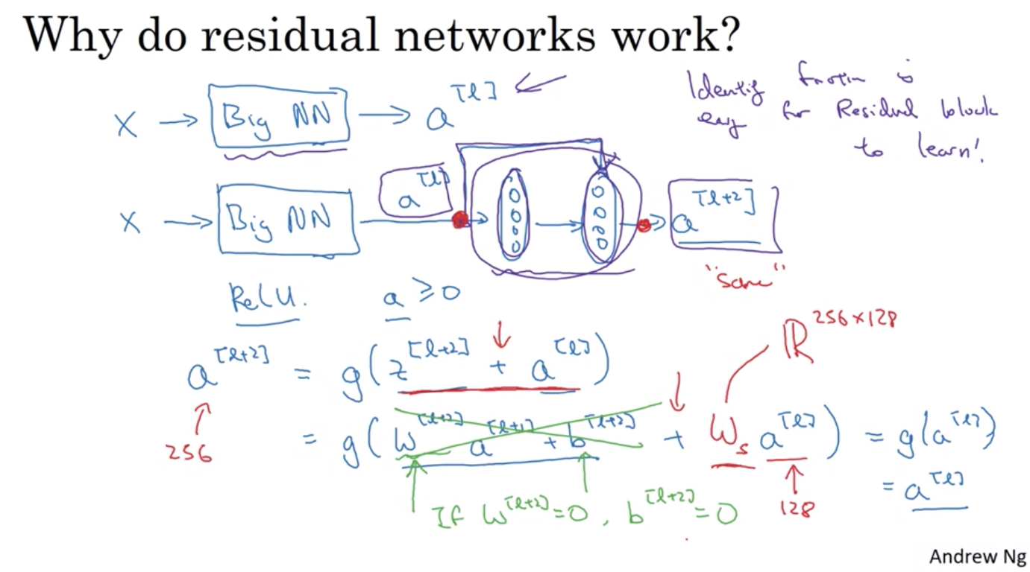

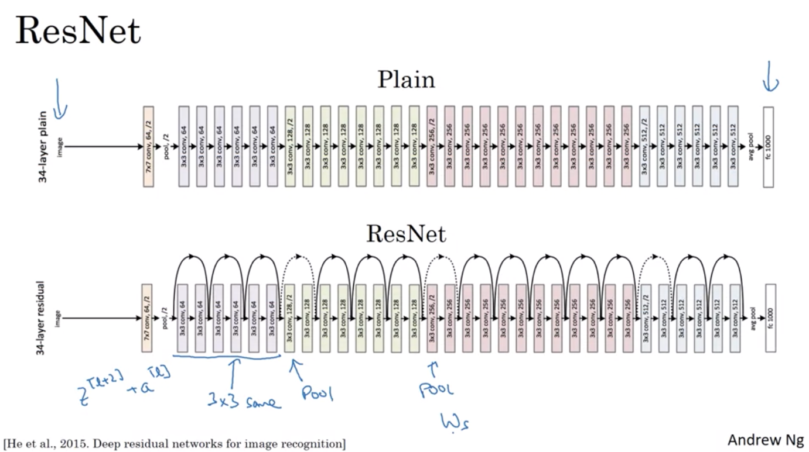

Network in Networks in 1x1 Convolution

* Helps build non-linearity in the neural networks : like adding a ReLu to a particular spot
* Help shrink the number of channels

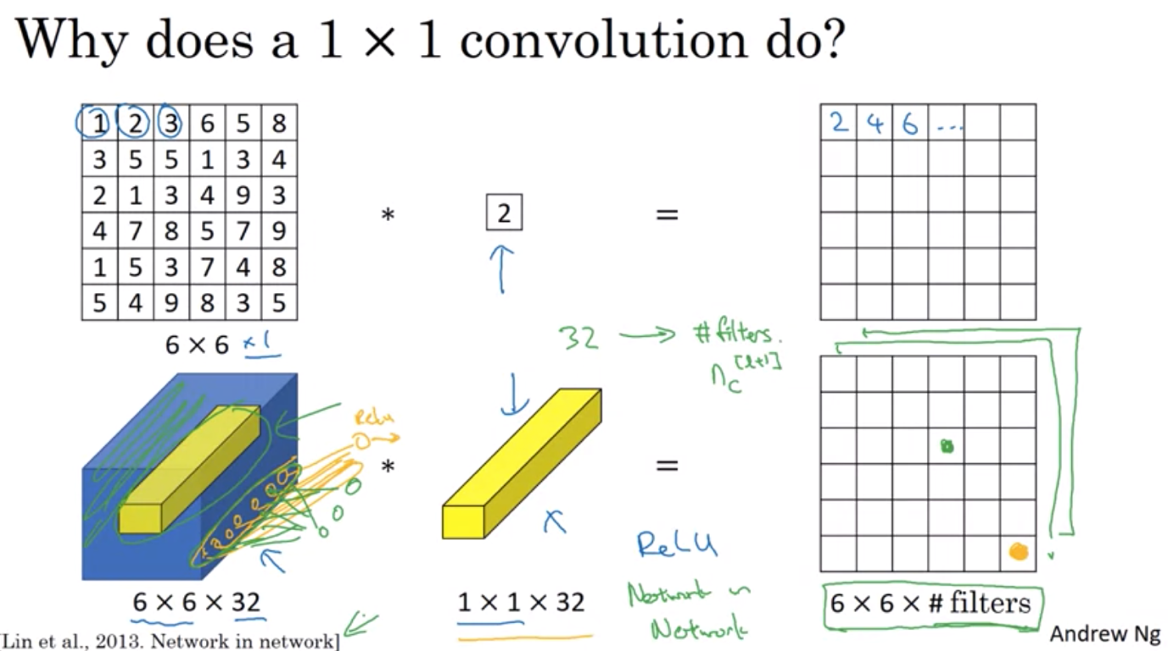

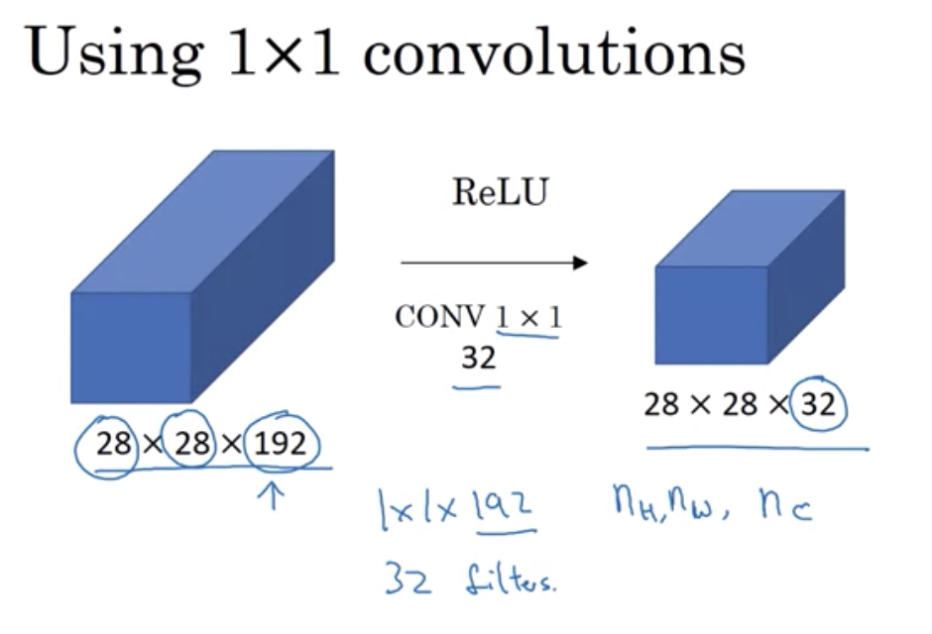

Inception Network

* Instead of having to choose what filter size you want in conv layer, conv or pooling layer? => let’s do them all in the inception layer and let the network choose what it wants to learn => concatenate them
* However, it’s quite computationally expensive => use 1x1 conv layer as the bottleneck layer to reduce the number of computations

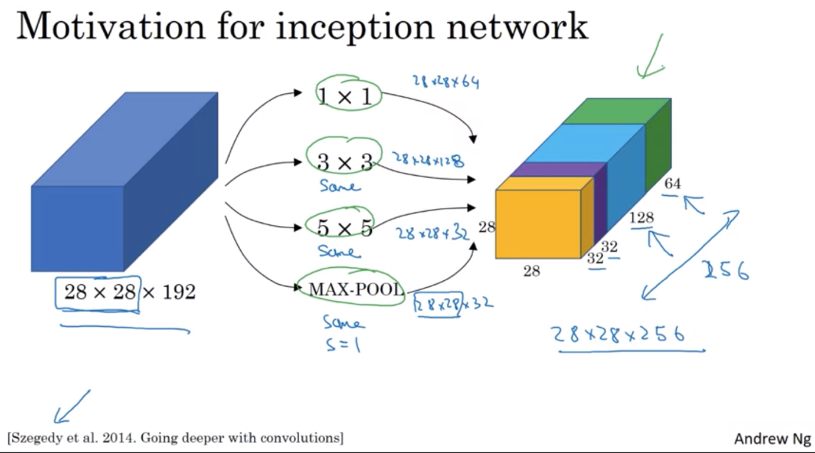

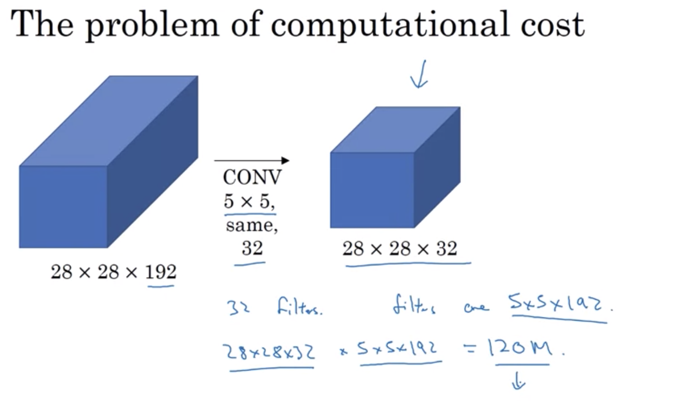

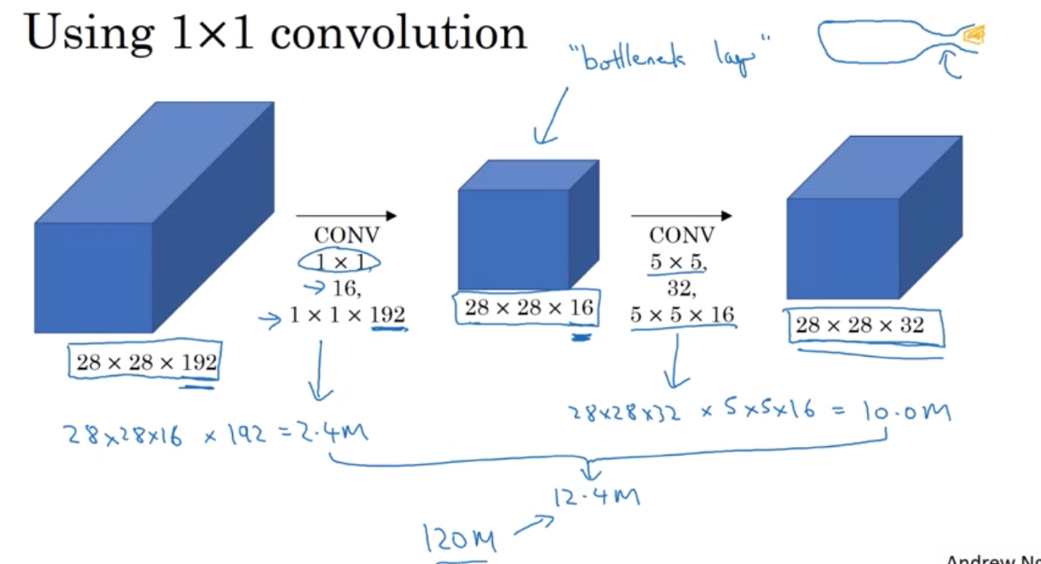

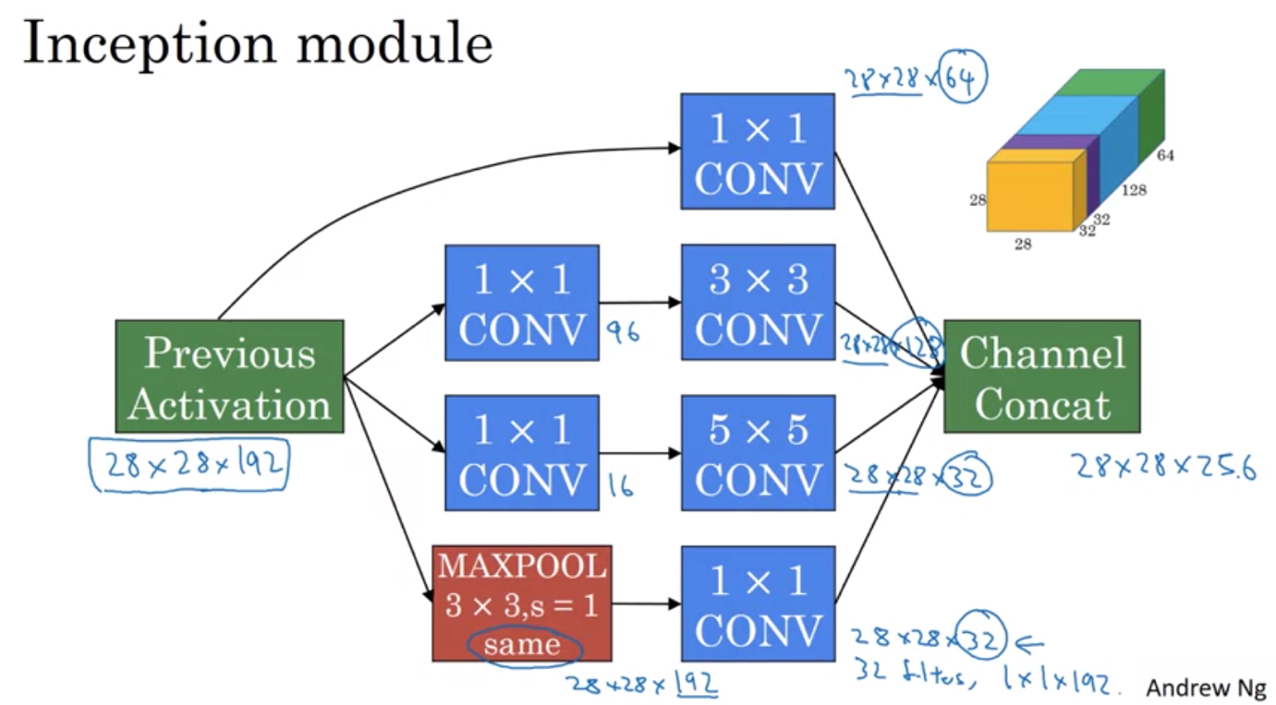

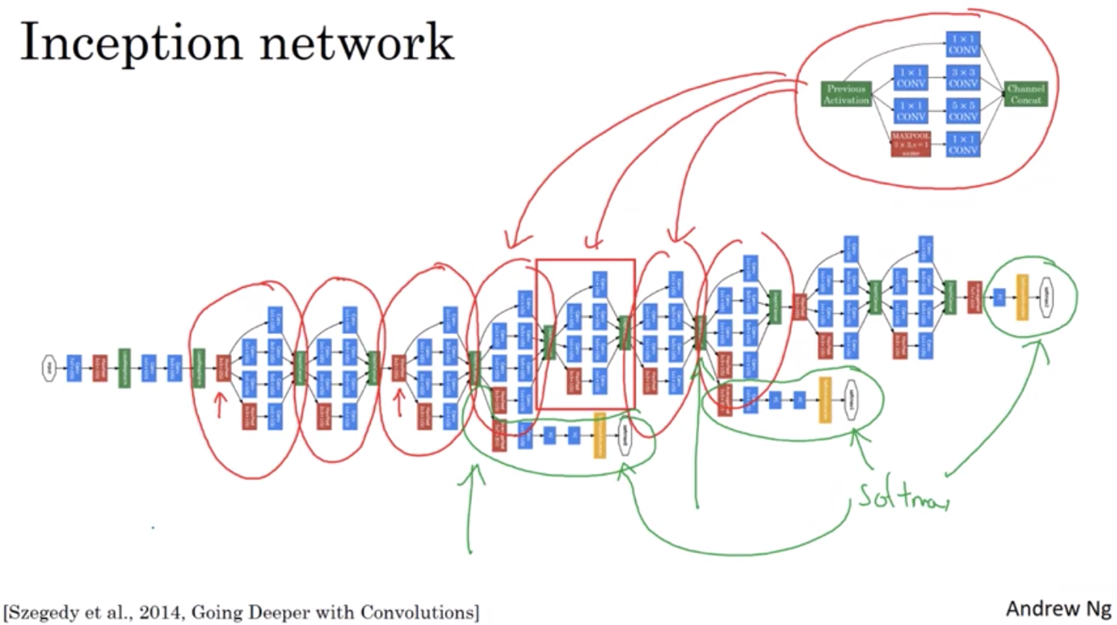

In the inception network: there’s some branches with softmax which helps to show that even on the earlier layers, the network is able to predict things. Also have regularization effect on the network.

TRANSFER LEARNING WITH OPEN SOURCE

* Computer vision is where transfer learning can be used extensively => use the weights already trained by others on your own similar problems

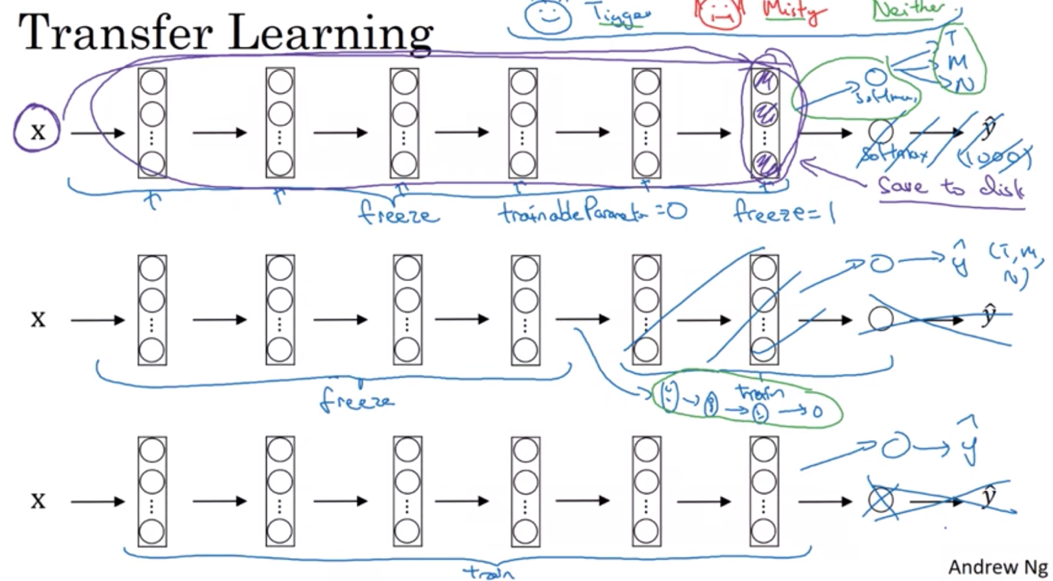

Data Augmentation:

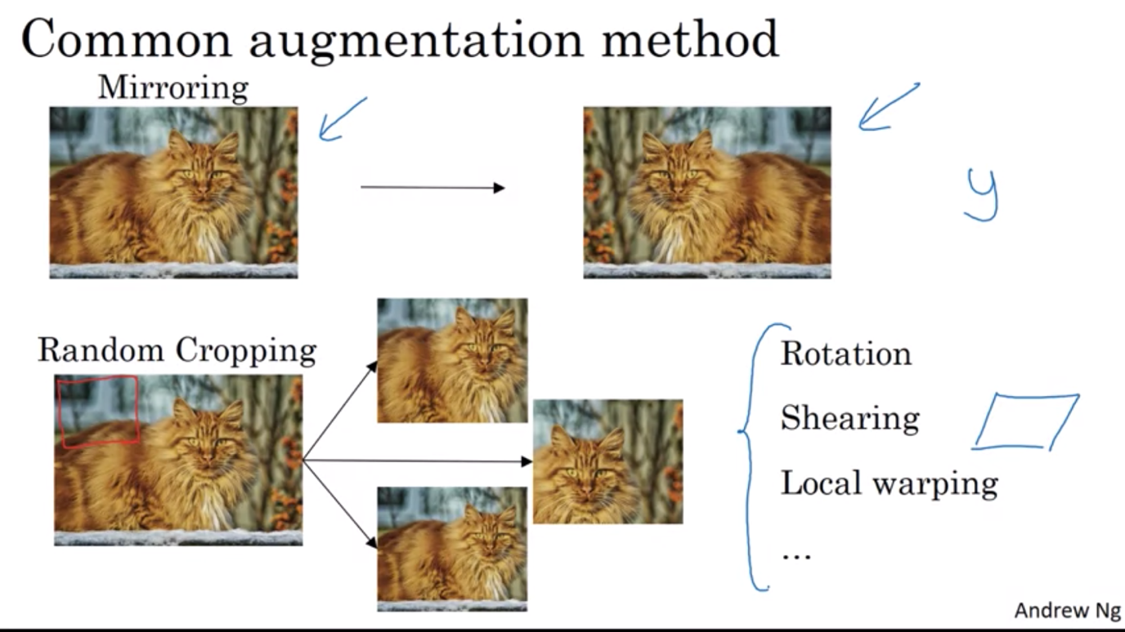

Color shift:

* Subtracting from the RGB channels, in practice, take RGB from a distribution
* Motivation: maybe change and shift in lighting condition in real life => help to make sure the model is robust to those conditions as well

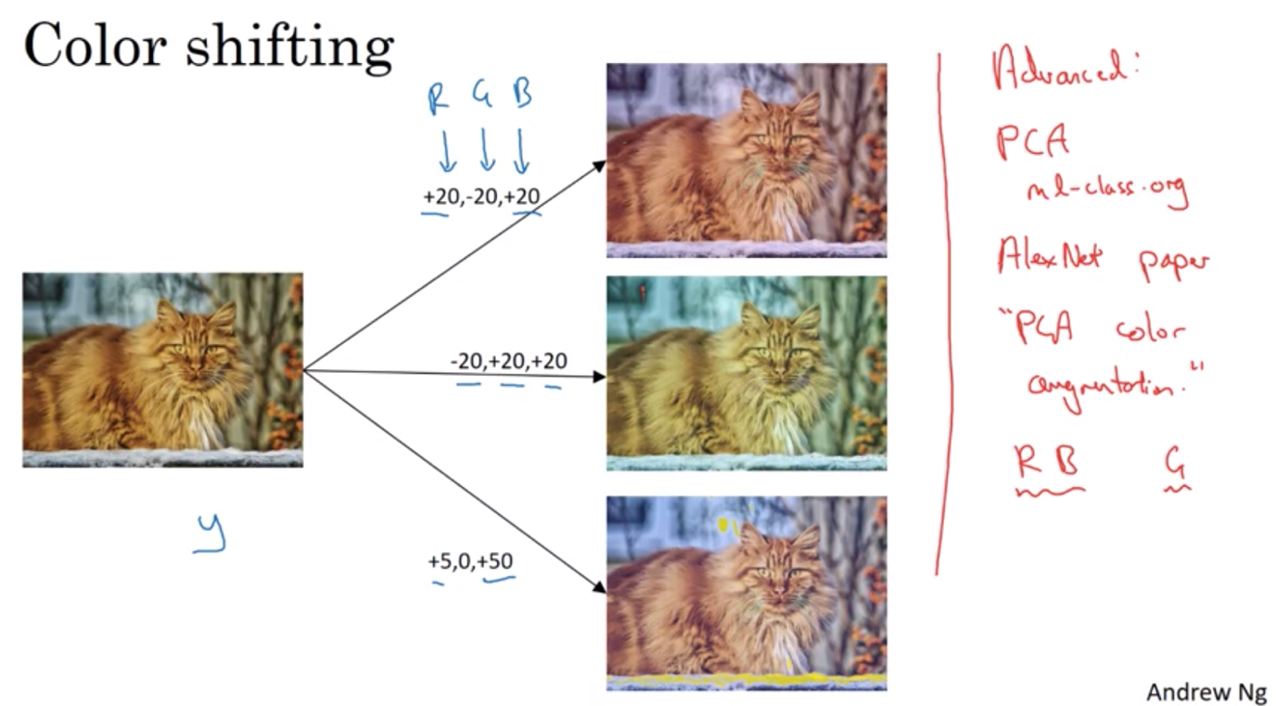

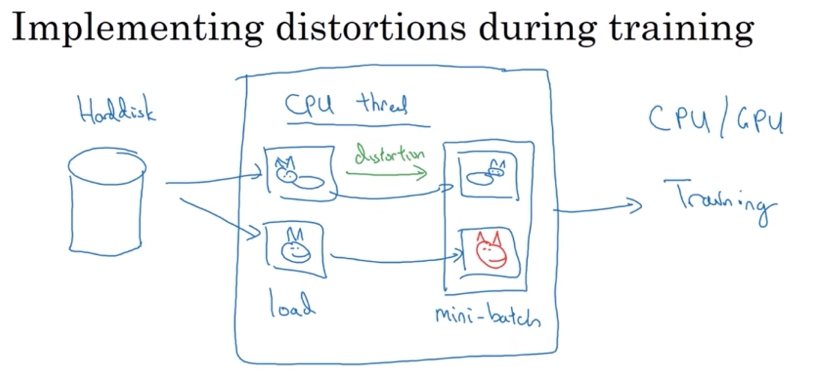

STATE OF COMPUTER VISION

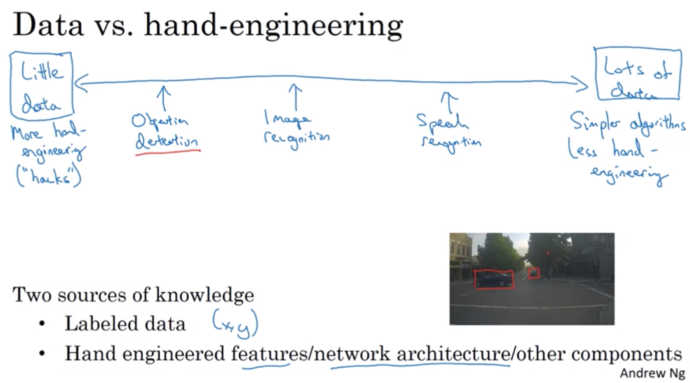

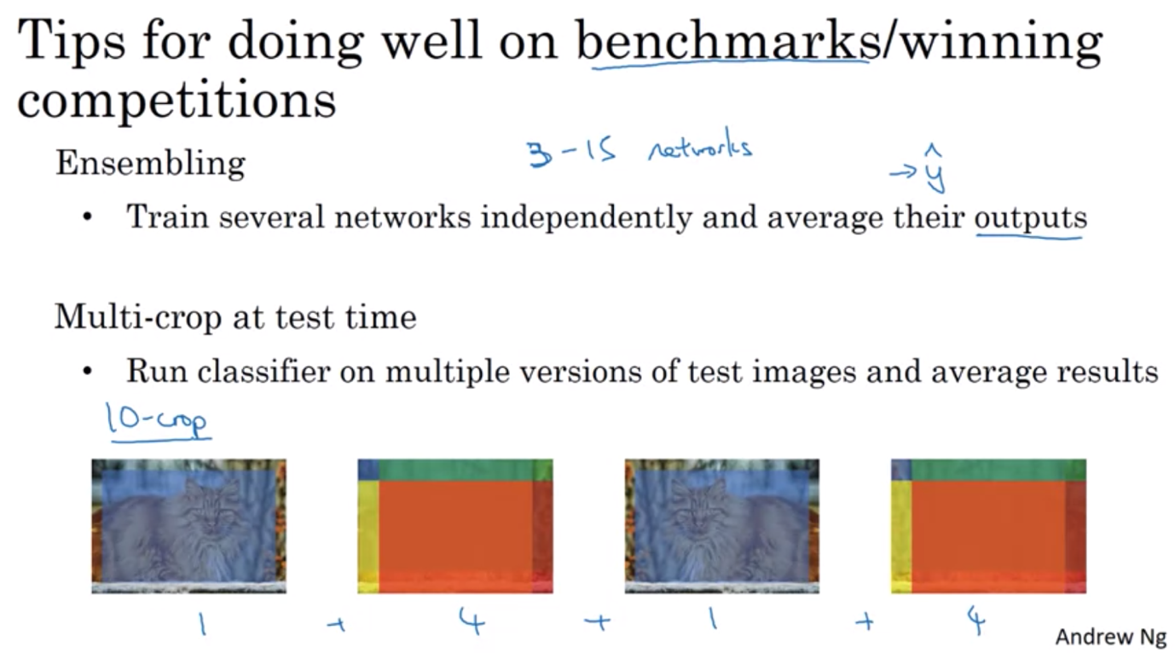

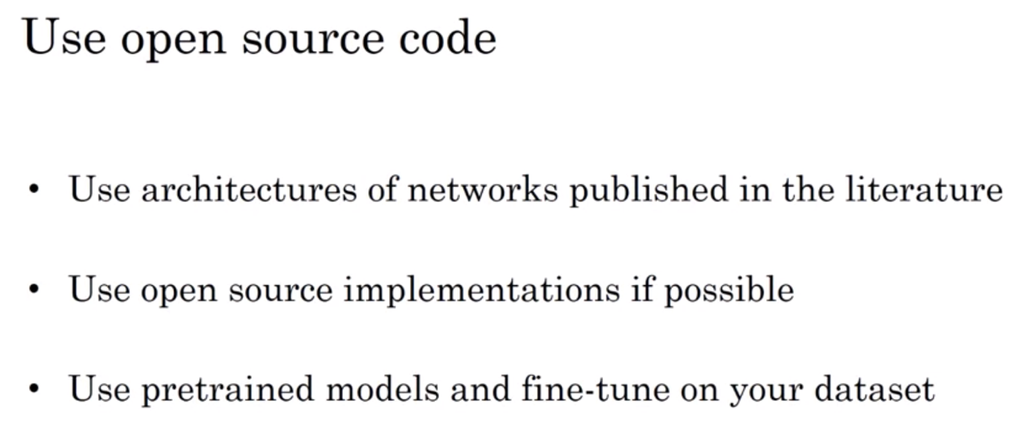

WEEK 3 – OBJECT DETECTION

Object localization

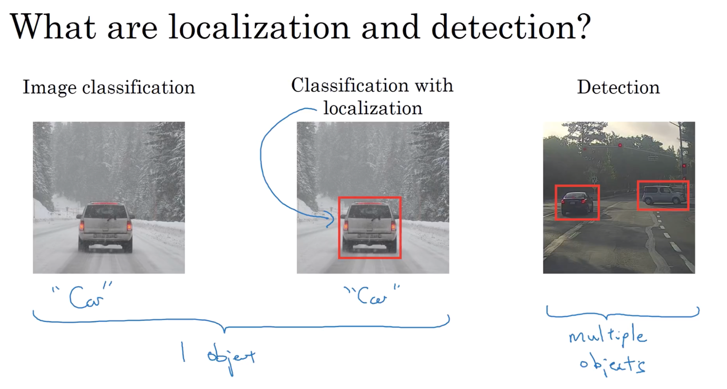

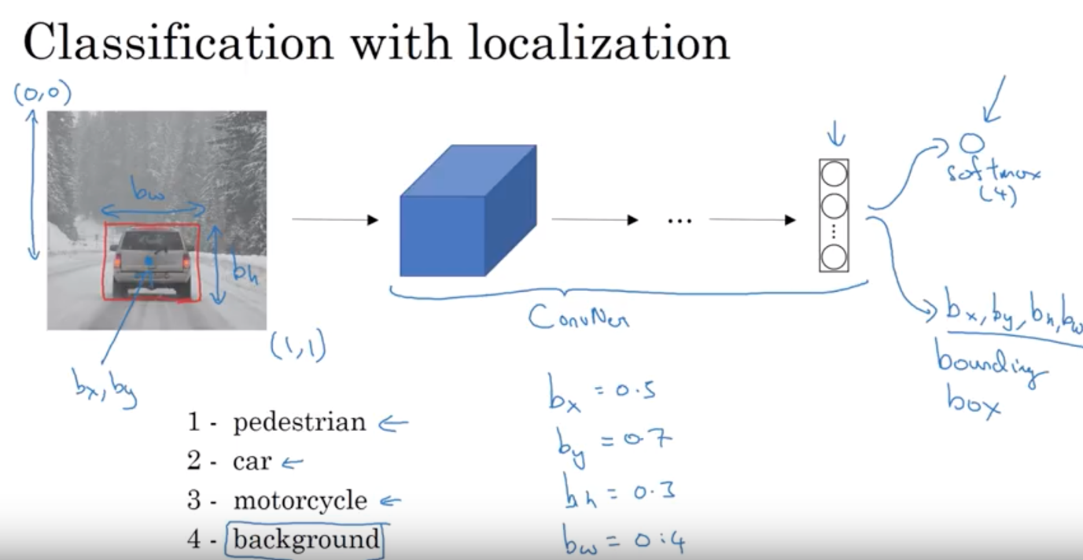

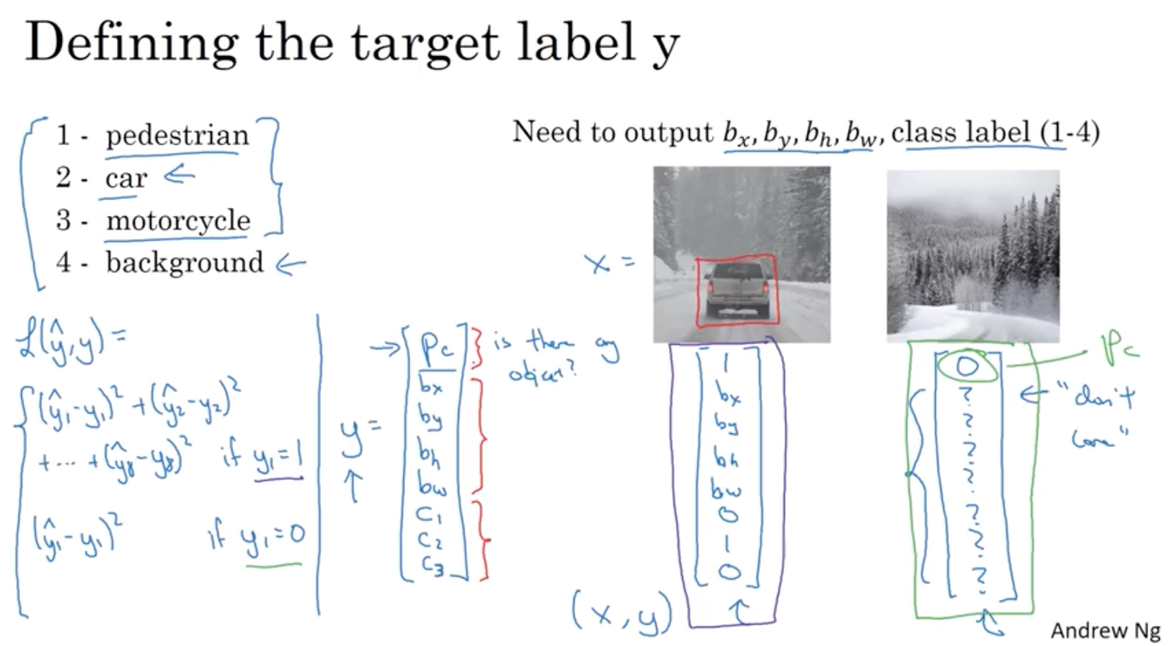

In practice:

* C1, c2, c3: usually use log likelihood loss
* Bx, by, bh, bw: square error
* Pc: logistic regression loss or square error

Landmark Detection

* The ability to detect landmarks in face: application in computer graphs, wrap effect on phone apps, take out facial features/expression to detect emotions / pose of a person

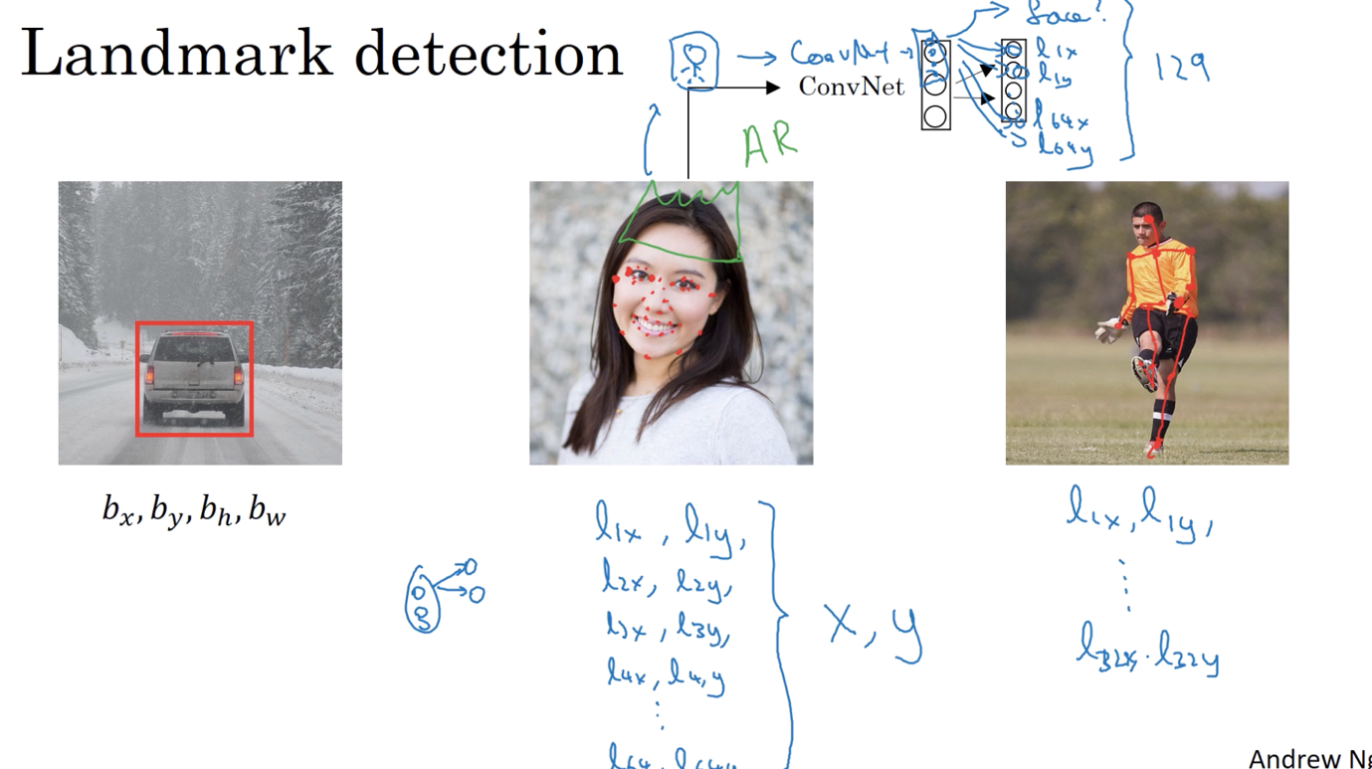

Object detection with sliding window algorithm

Use Convnet to detect car first => then use sliding window

Problem with sliding window: if window size is small: huge computational cost => has to compute each region of the sliding window individually; if window size is big => lose granularity of the detection

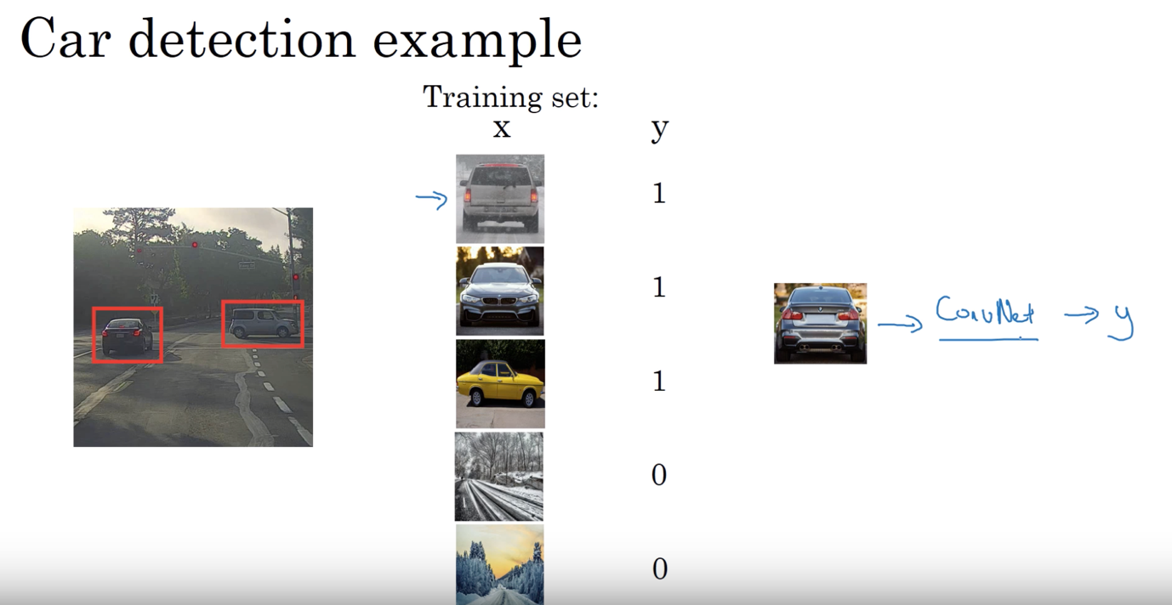

Convolutional implementation of sliding windows

Turning FC layers into convolutional layers

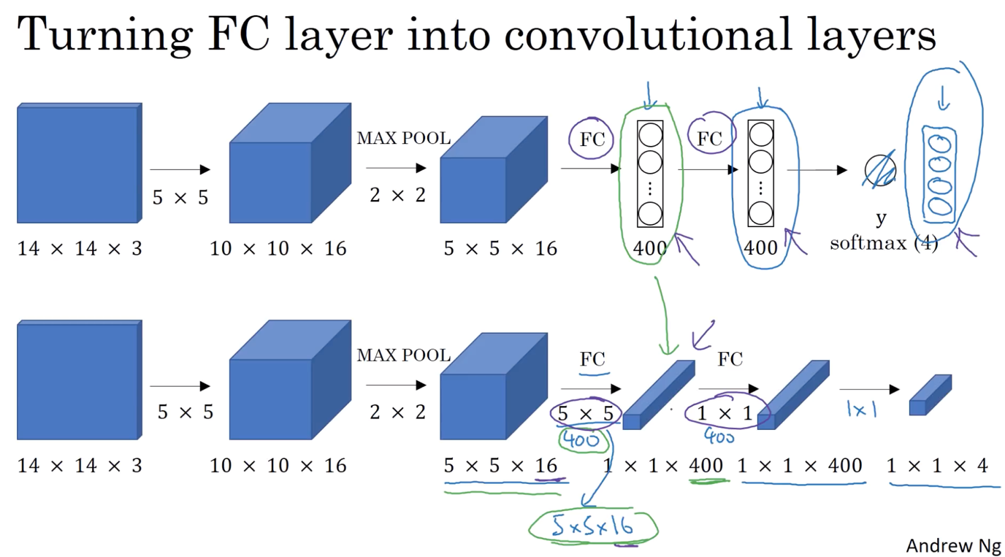

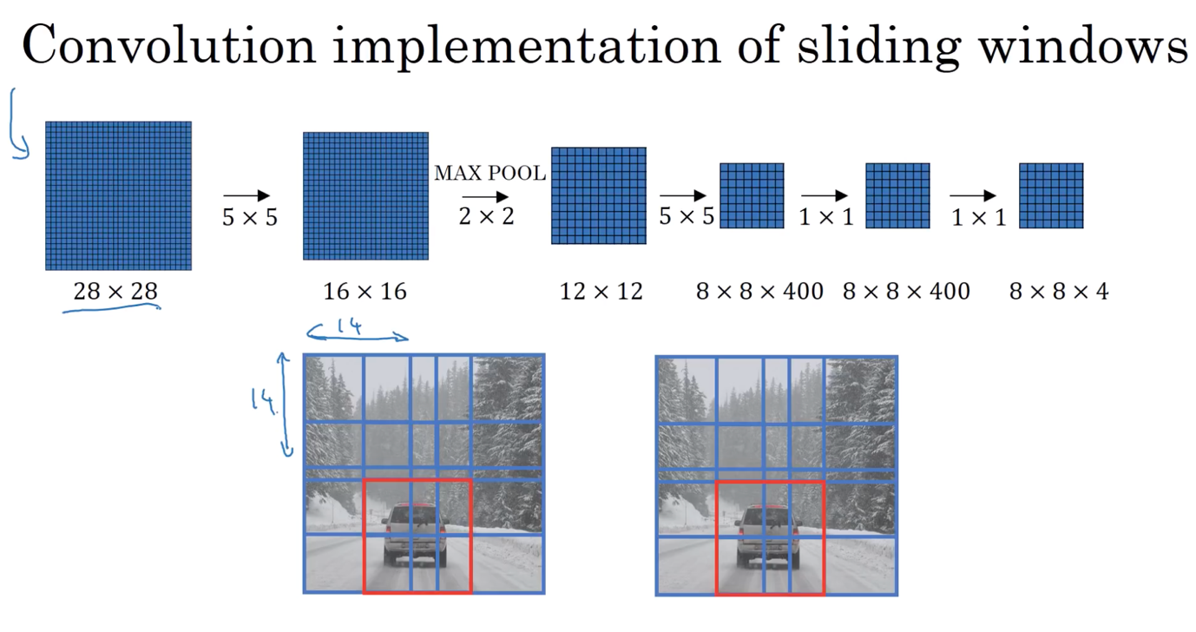

Bounding box predictions

* With sliding window, you cannot get the exact match of the box on the car.
* The perfect box is also not quite square but a bit rectangle

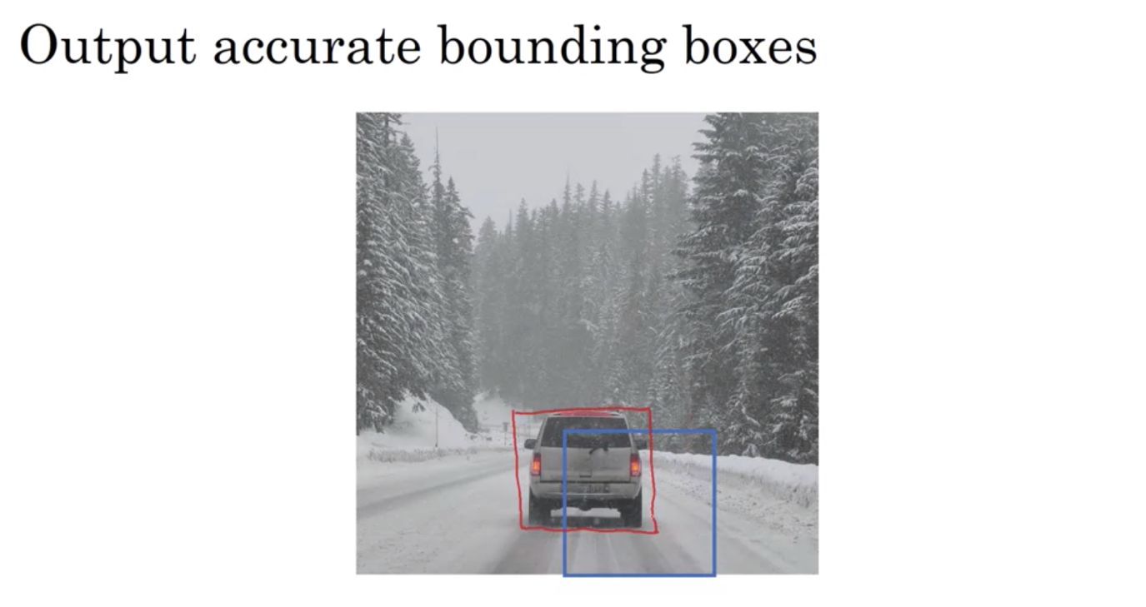

YOLO algorithm:

* Divide image into grids: run object localization and detection to define the desired object in each grid

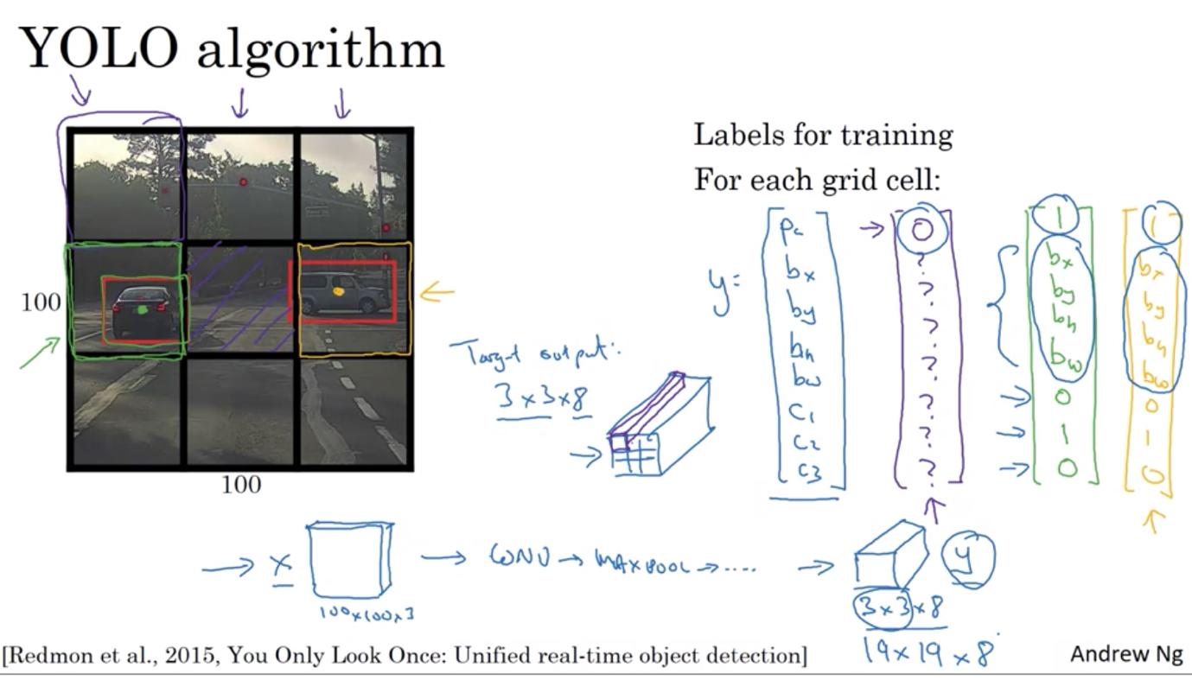

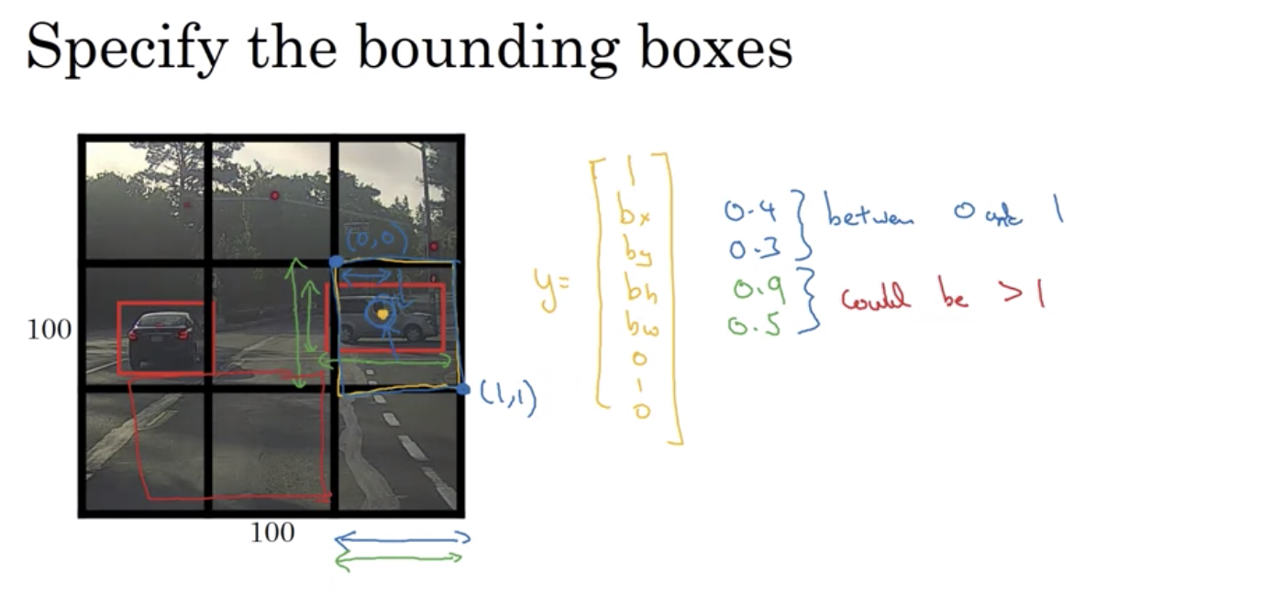

Intersection over union:

* Used to evaluate object detection algorithm
* Add another component to object detection algorithm to make it even better
* Use IoU: the higher it is, the more correct the bounding box is

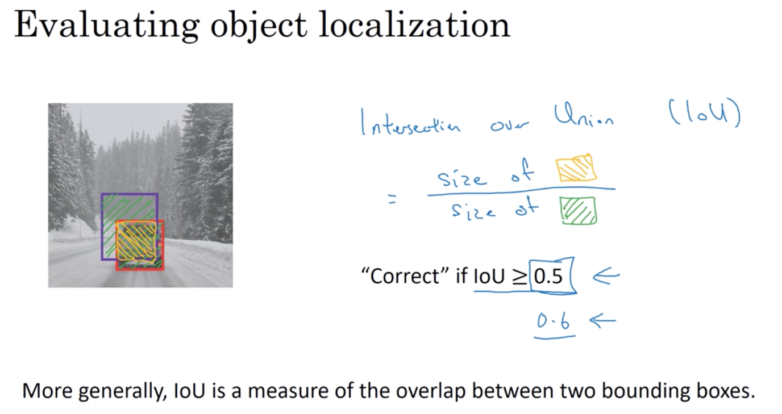

Nonmax Suppresion:

* Make sure your algorithm does not find one thing multiple times => clean up multiple detection
* Look at the max value => look at the other box with high IoU => get rid of them
* All boxes are either highlighted or darkened => get rid of the darkened ones

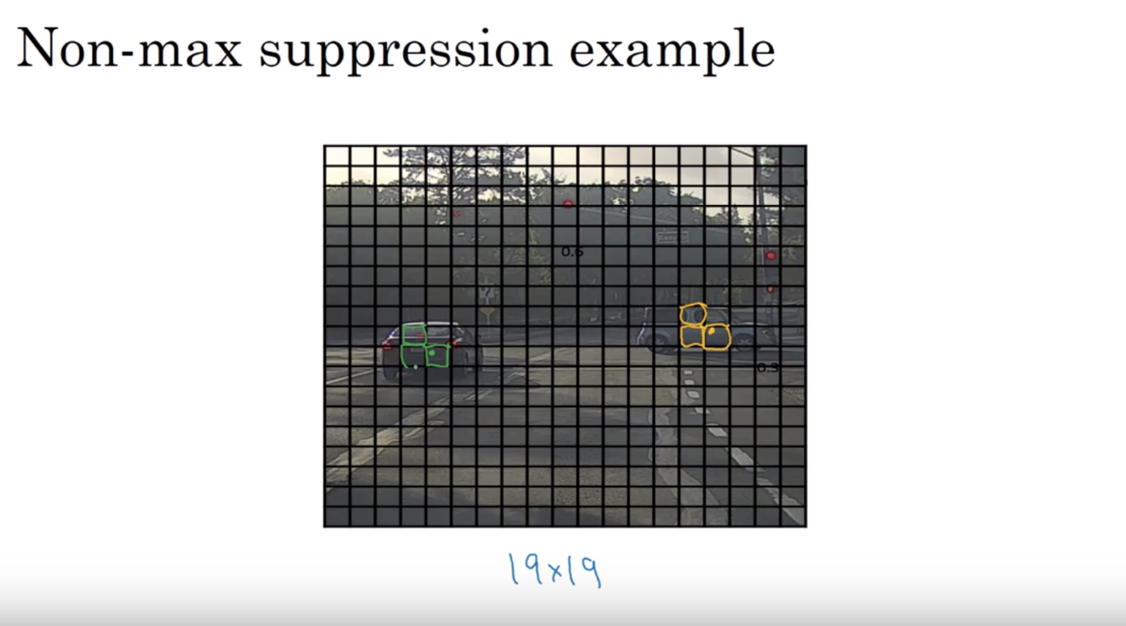

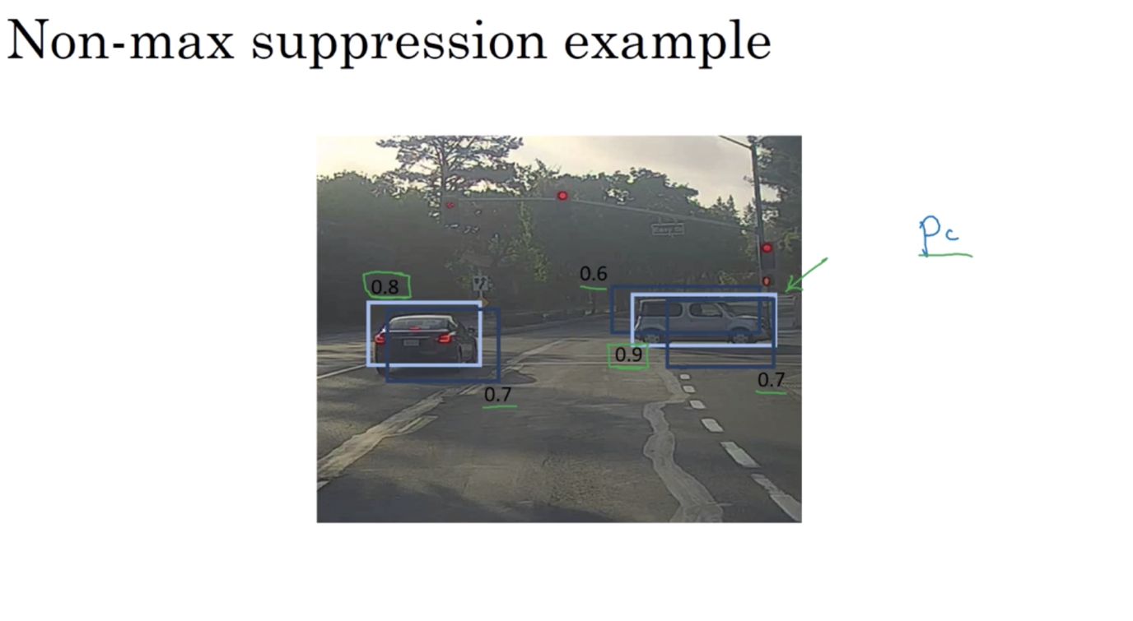

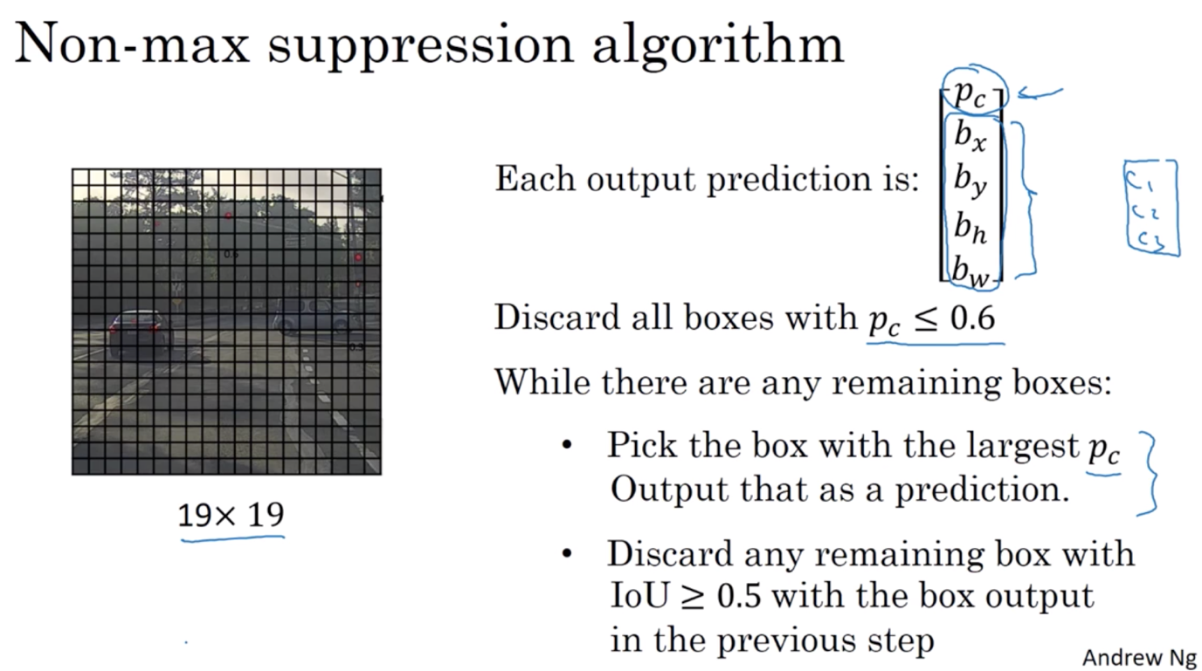

Anchor boxes: predefine boxes for detection of different objects with the same midpoint

* Helps your algorithm to specialize better: able to detect tall skinny objects like person and long objects like cars
* More advanced version: use k-means to automatically create anchor boxes

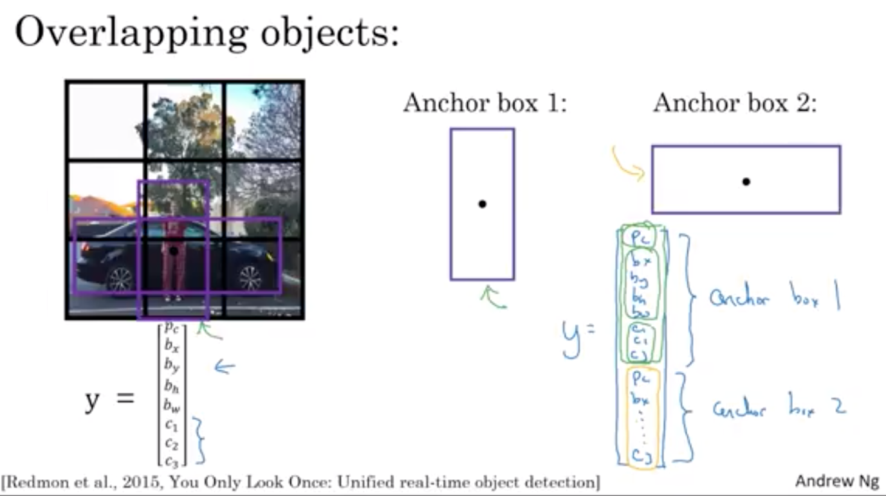

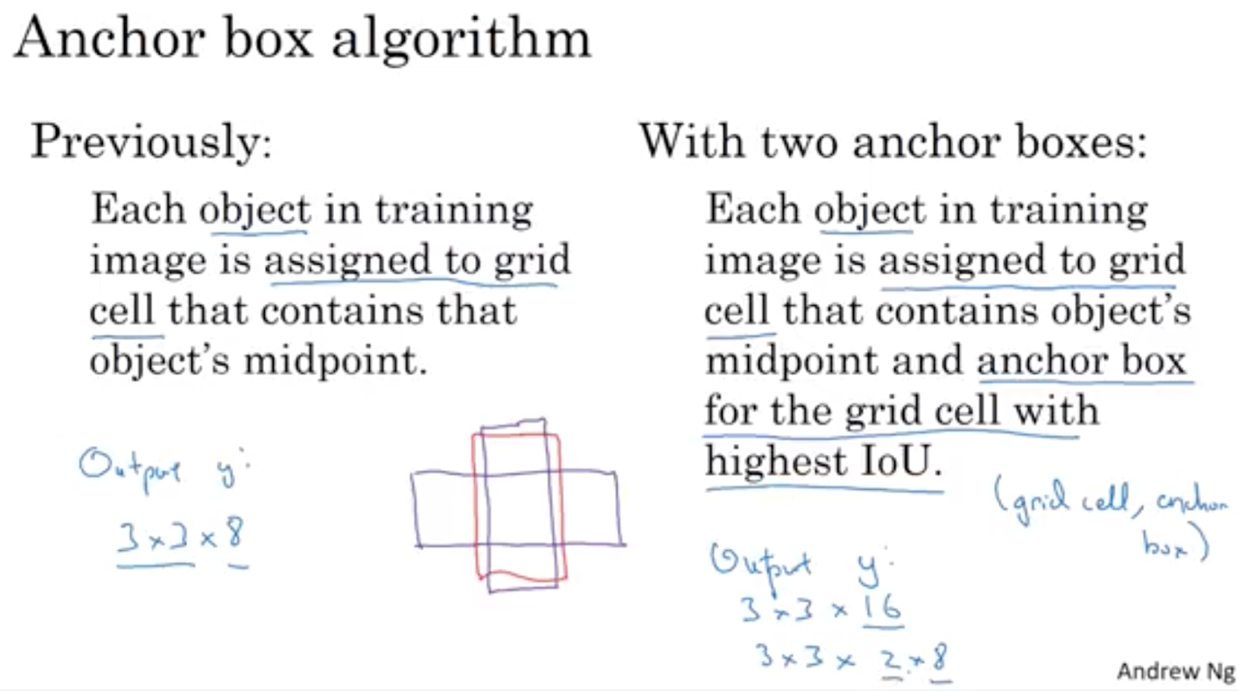

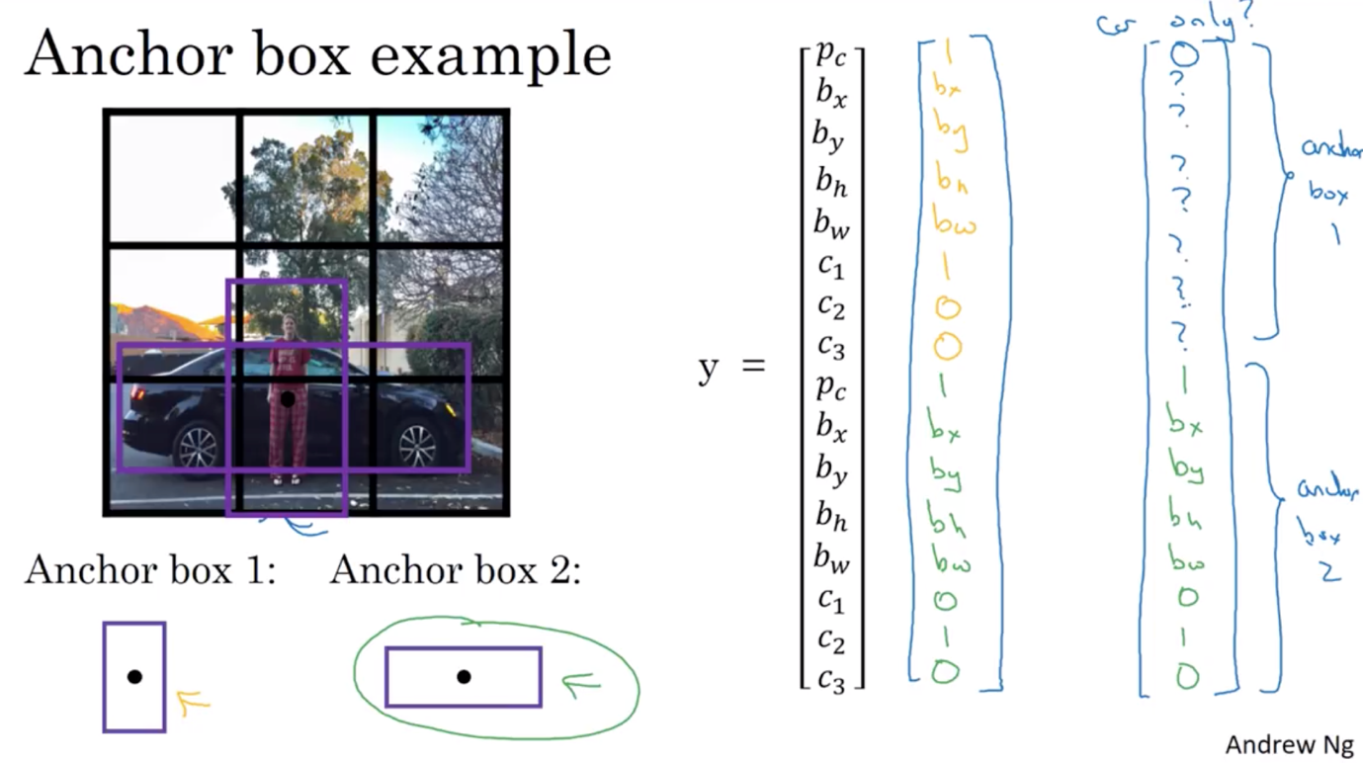

Putting it all together

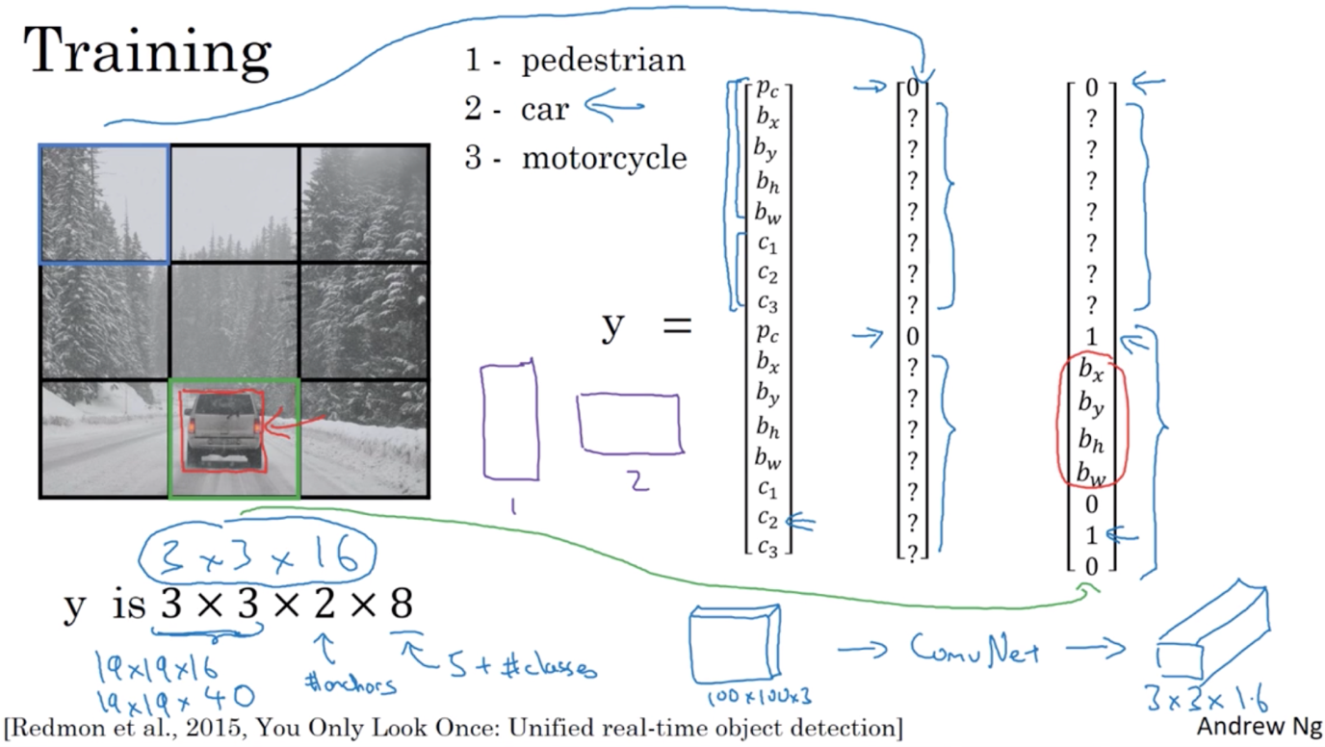

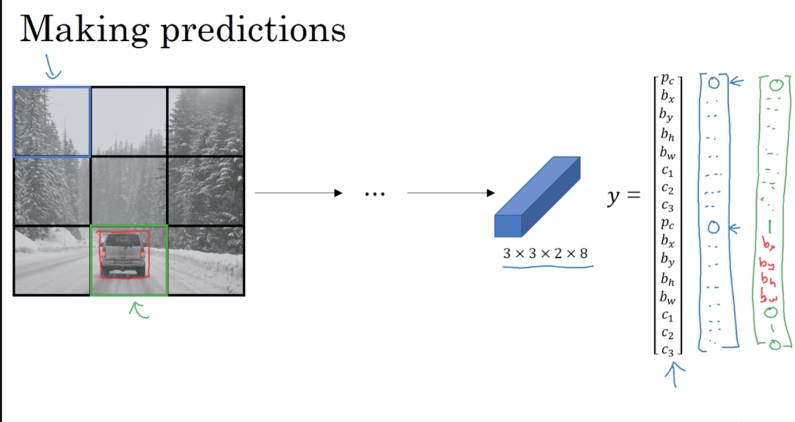

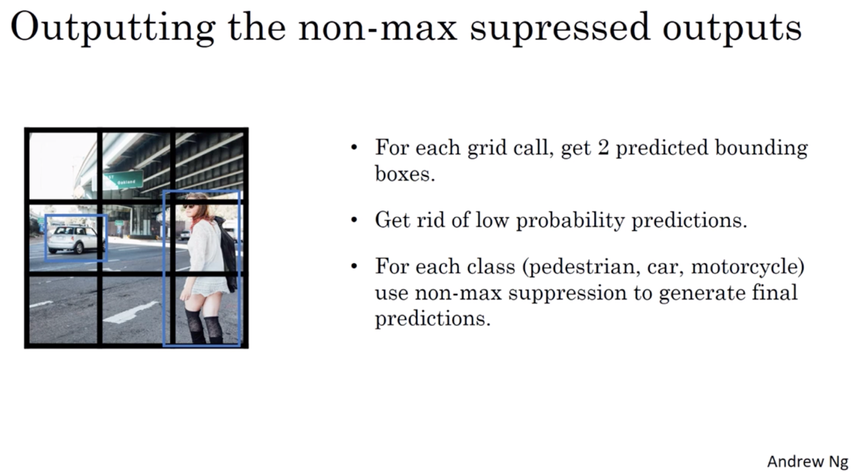

Region Proposals

R-CNN: only pick the region that is reasonable to run classifier on, not all image contain the object we want to detect => select only a few of the sliding window and run convnet on that

* Run segmentation algorithm to see what objects can be detected: run classifier only on the blobs of color that are found

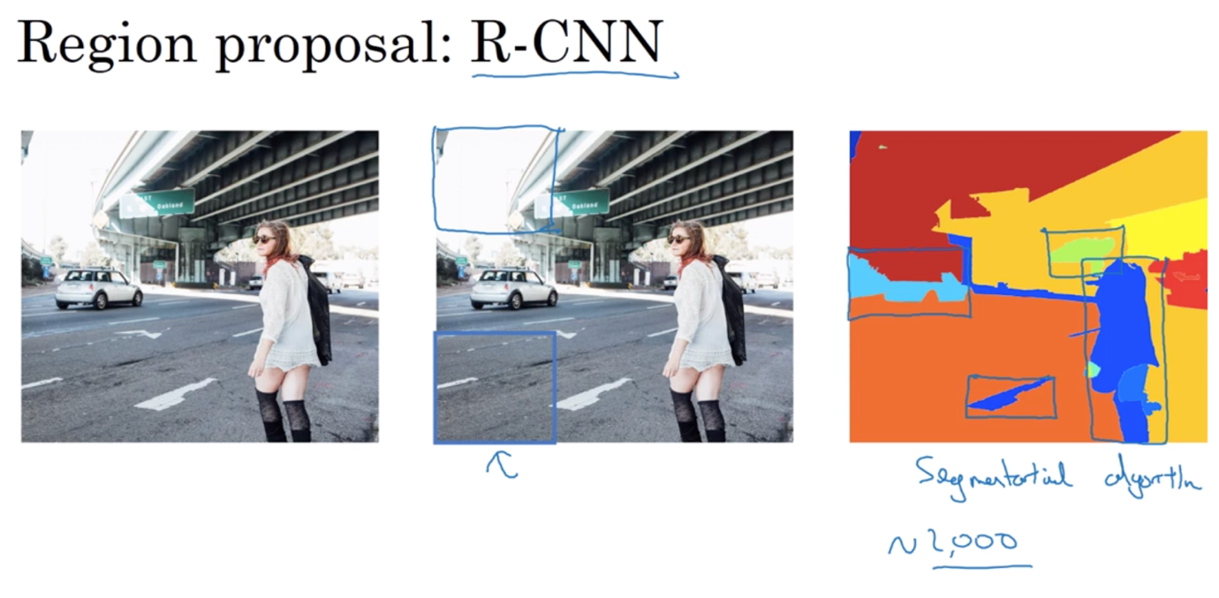

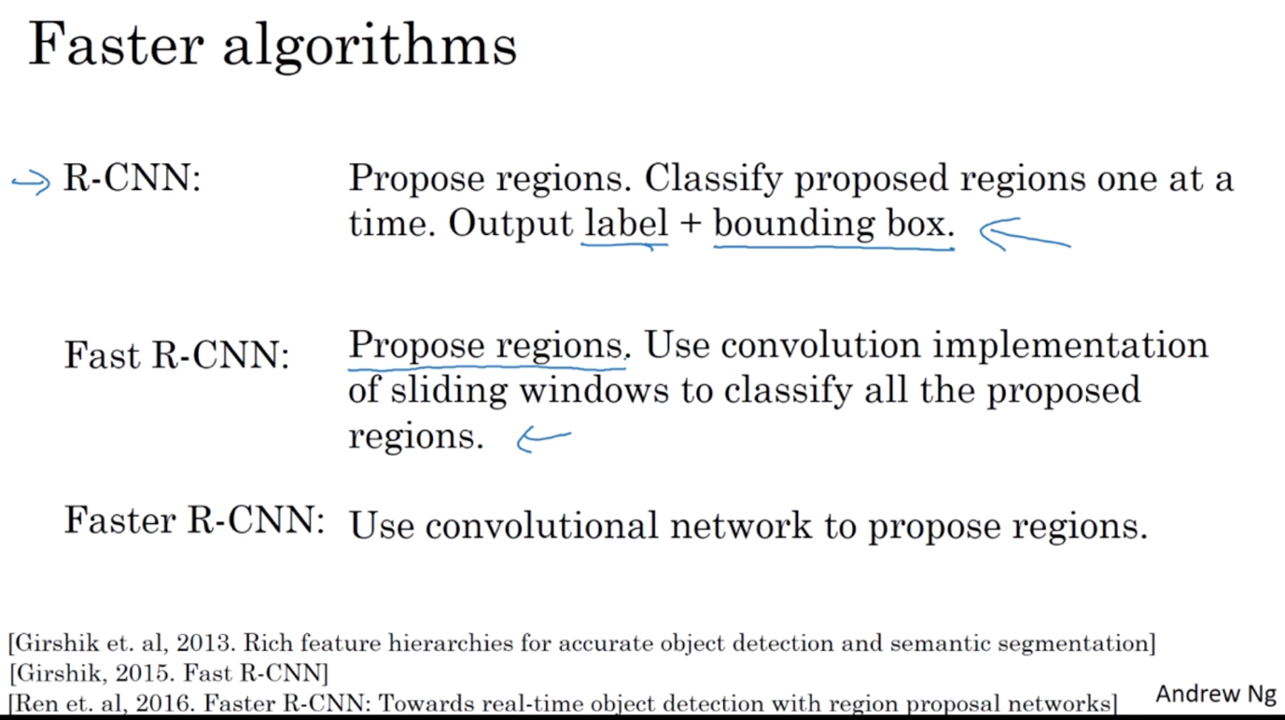

Week 4 –

Face Recognition

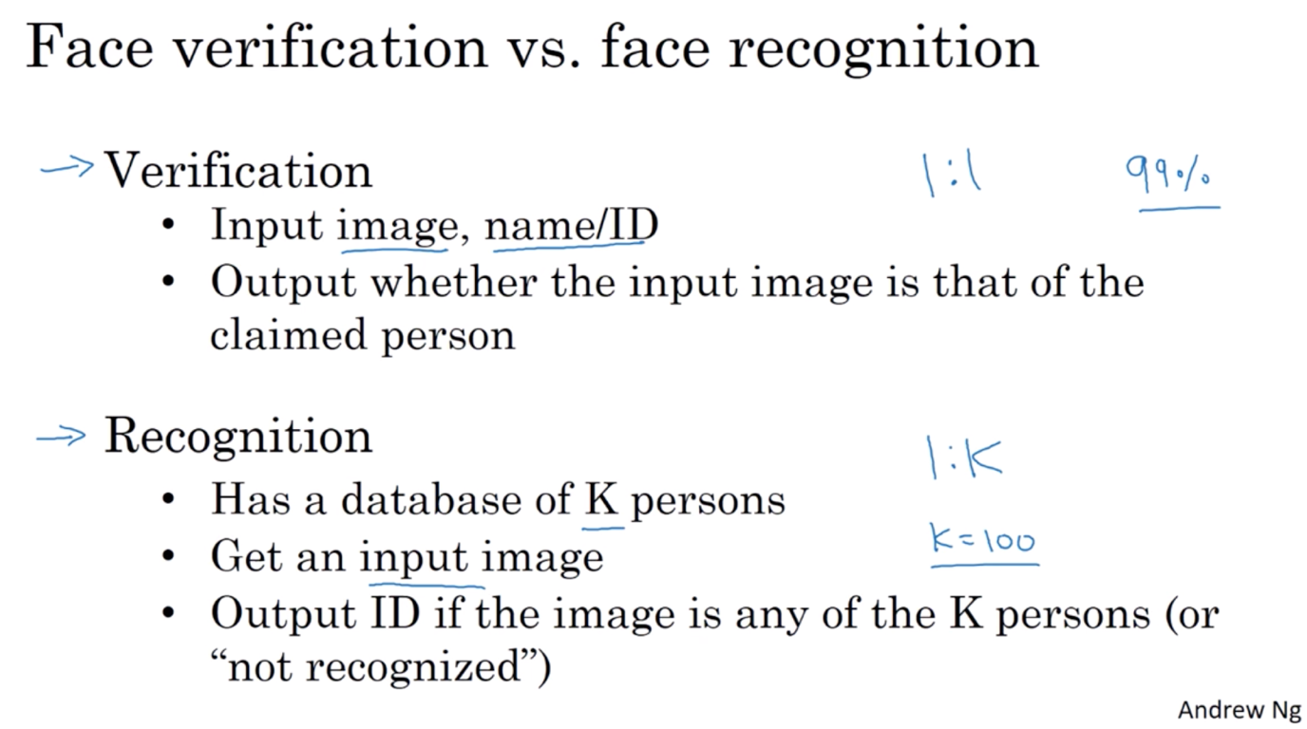

One shot learning

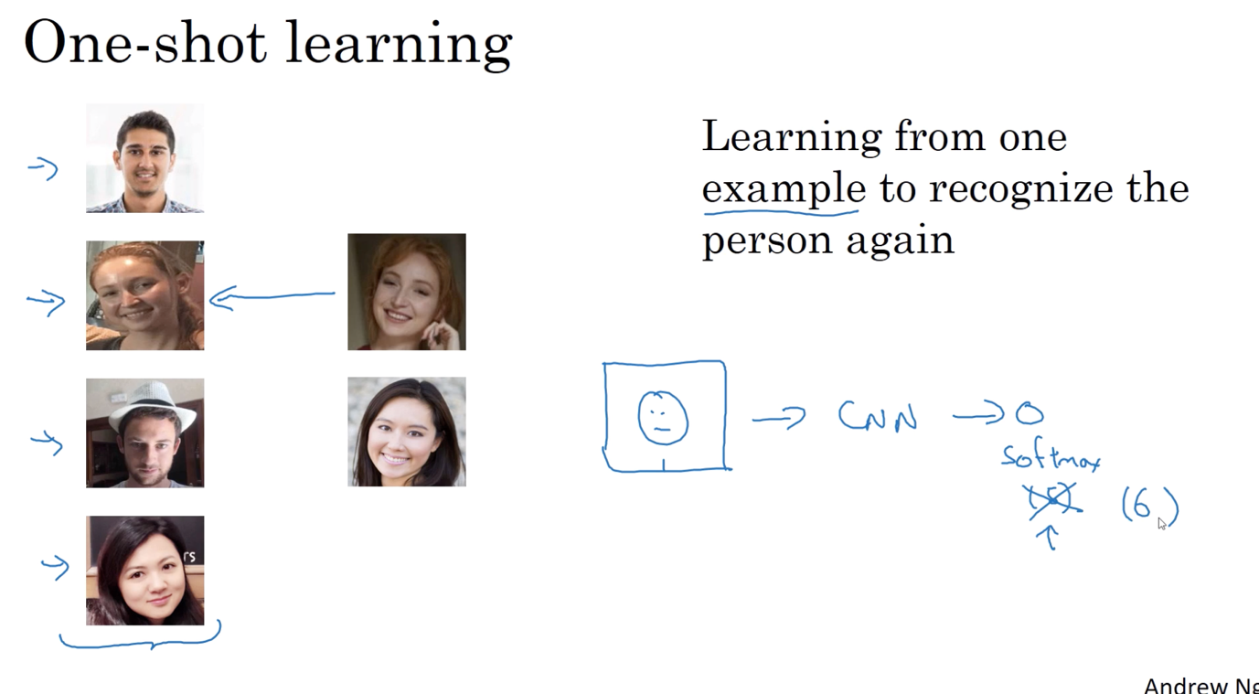

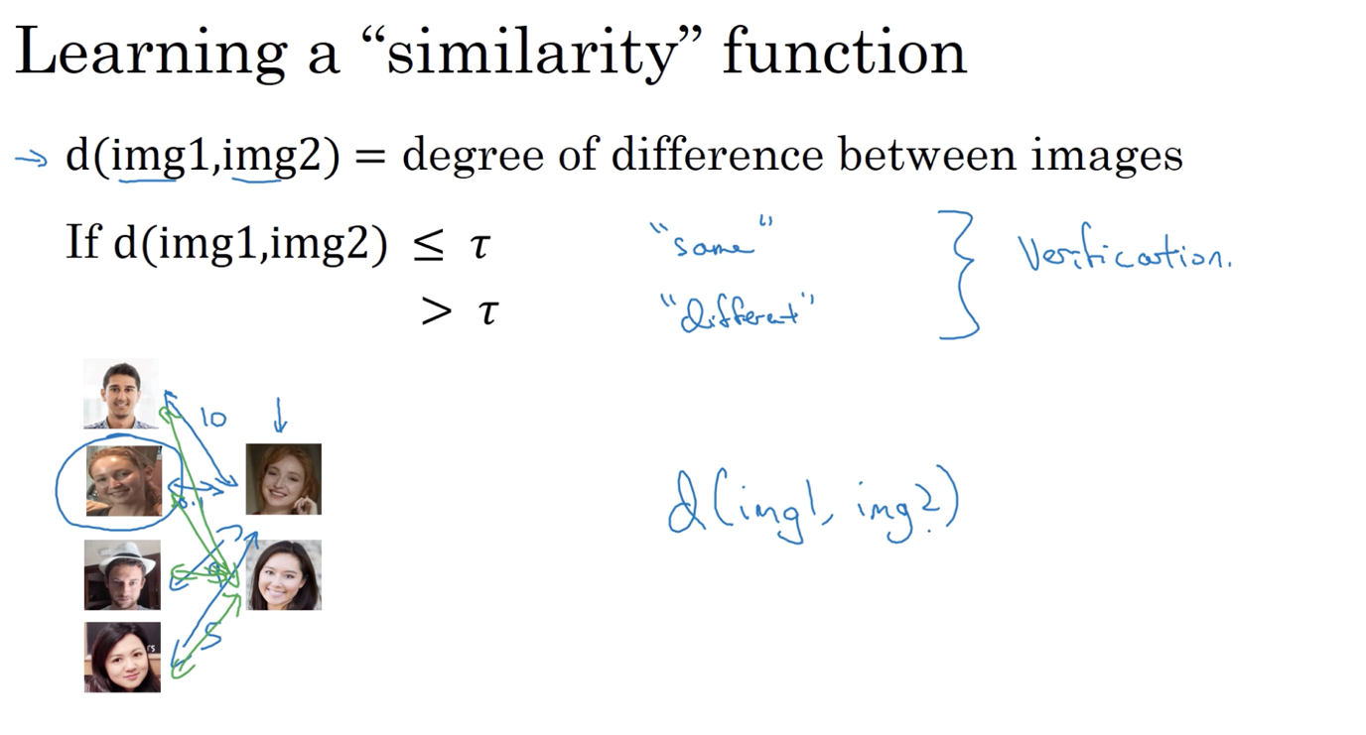

A funtion d to tell the difference between two pictures

Siamese Network

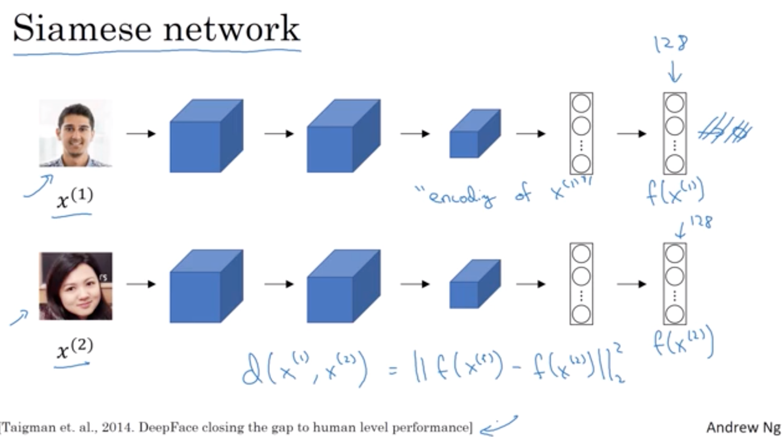

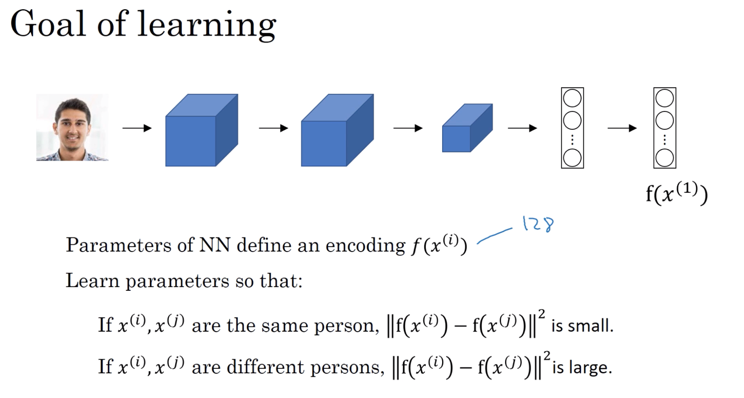

Triplet loss

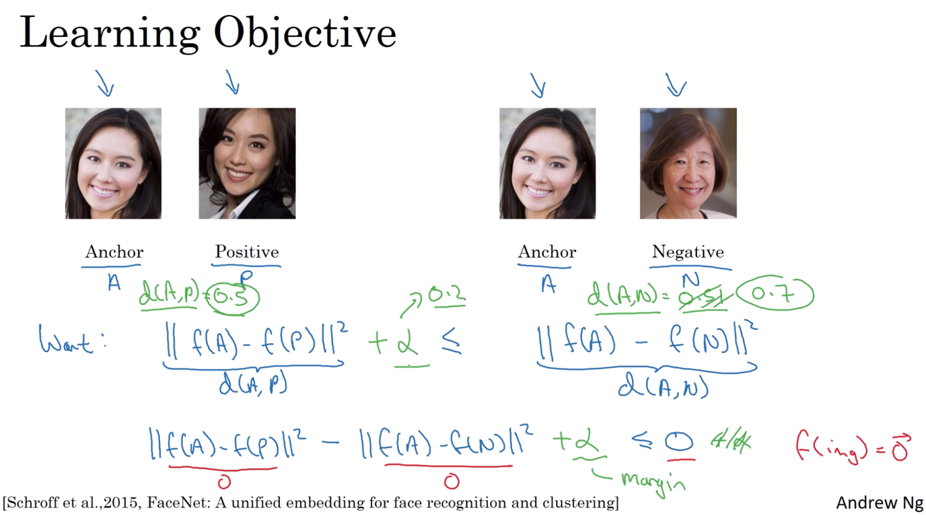

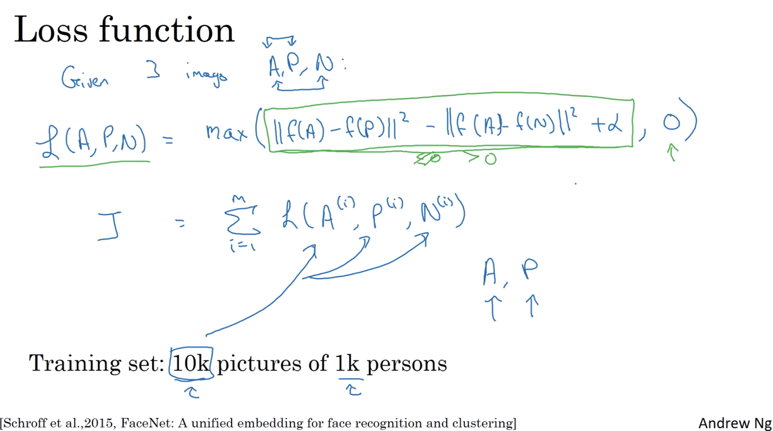

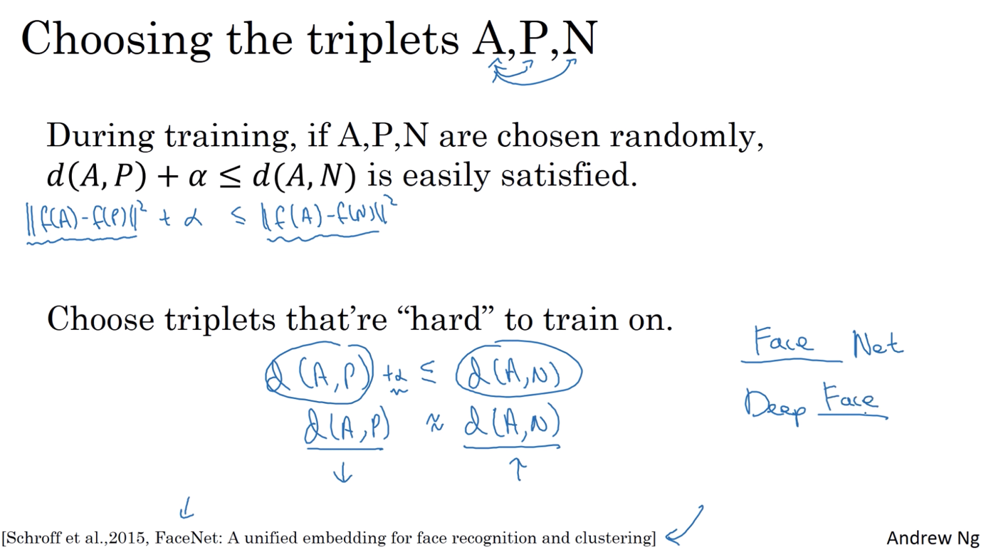

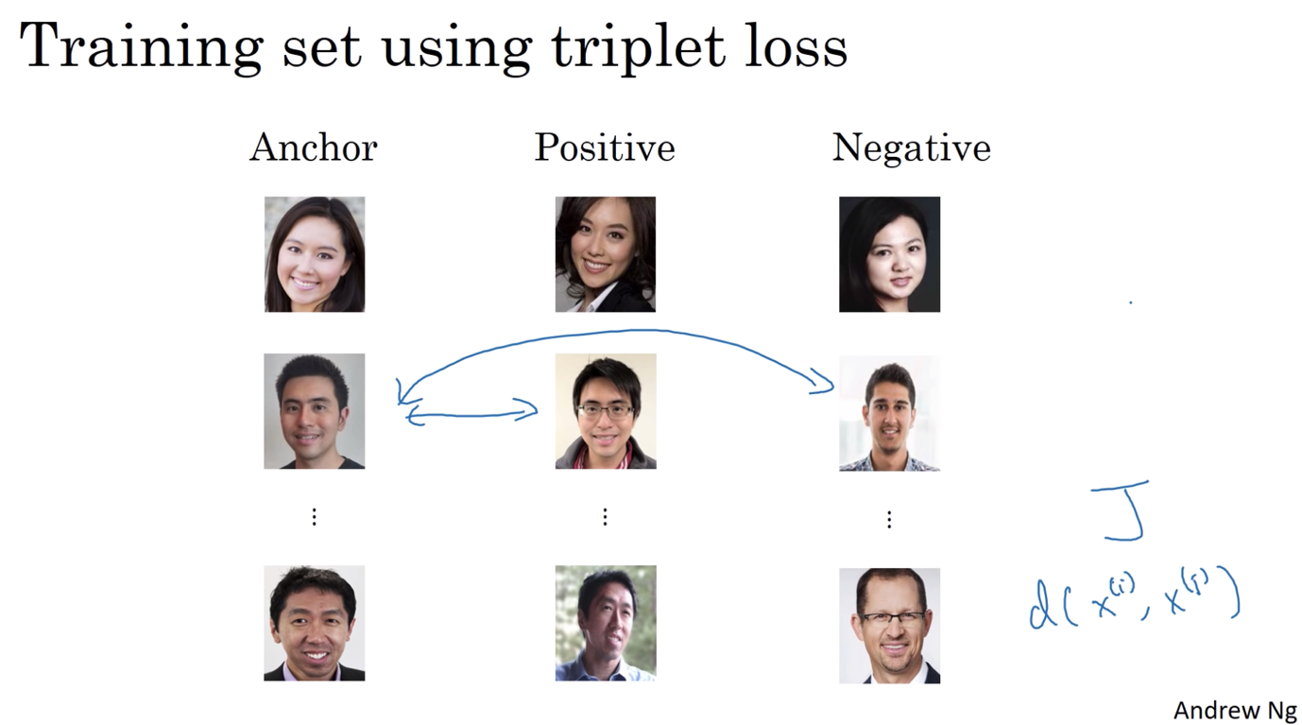

Face Verification

Another method:

* Treat face recognition just as binary classification problem
* Use different pairs to train the gradient descent in the Siamese network

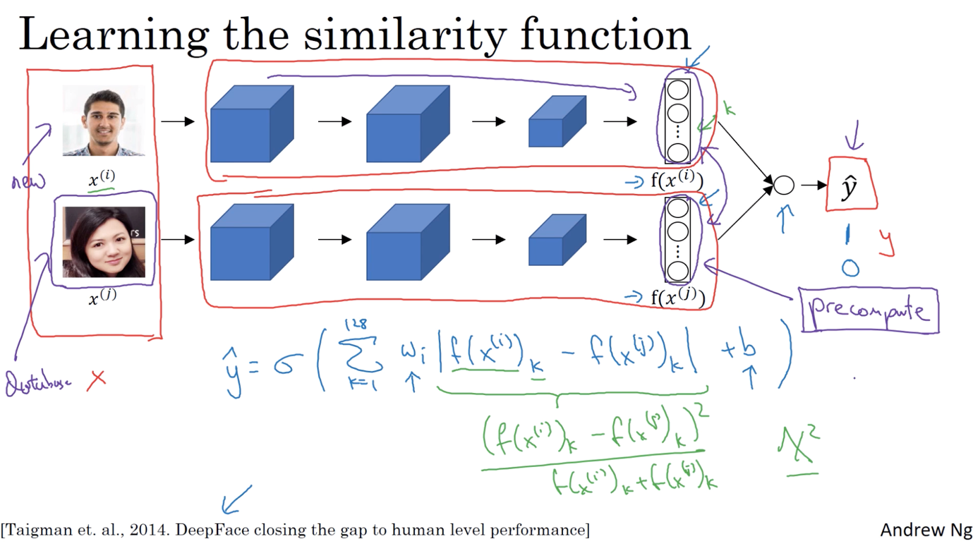

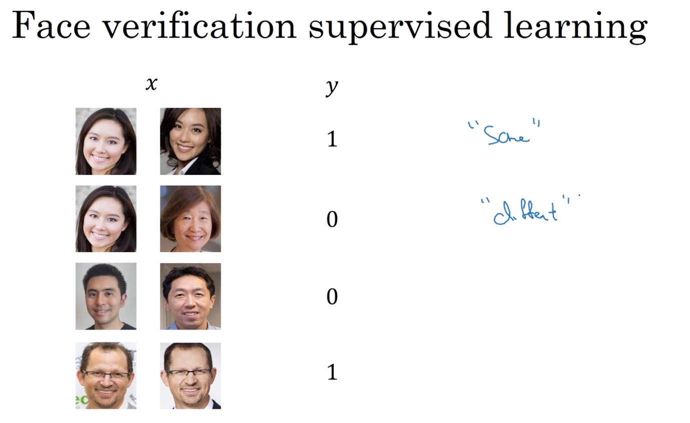

NEURAL STYLE TRANSFER

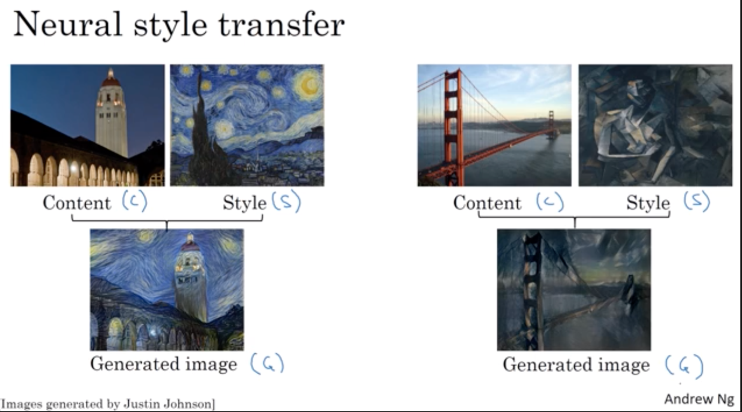

Deep CNs Learning

* The earlier unit learns about small features while the layer learns about large features/patches of the images
* Each layer learns a larger/more complex component of the images

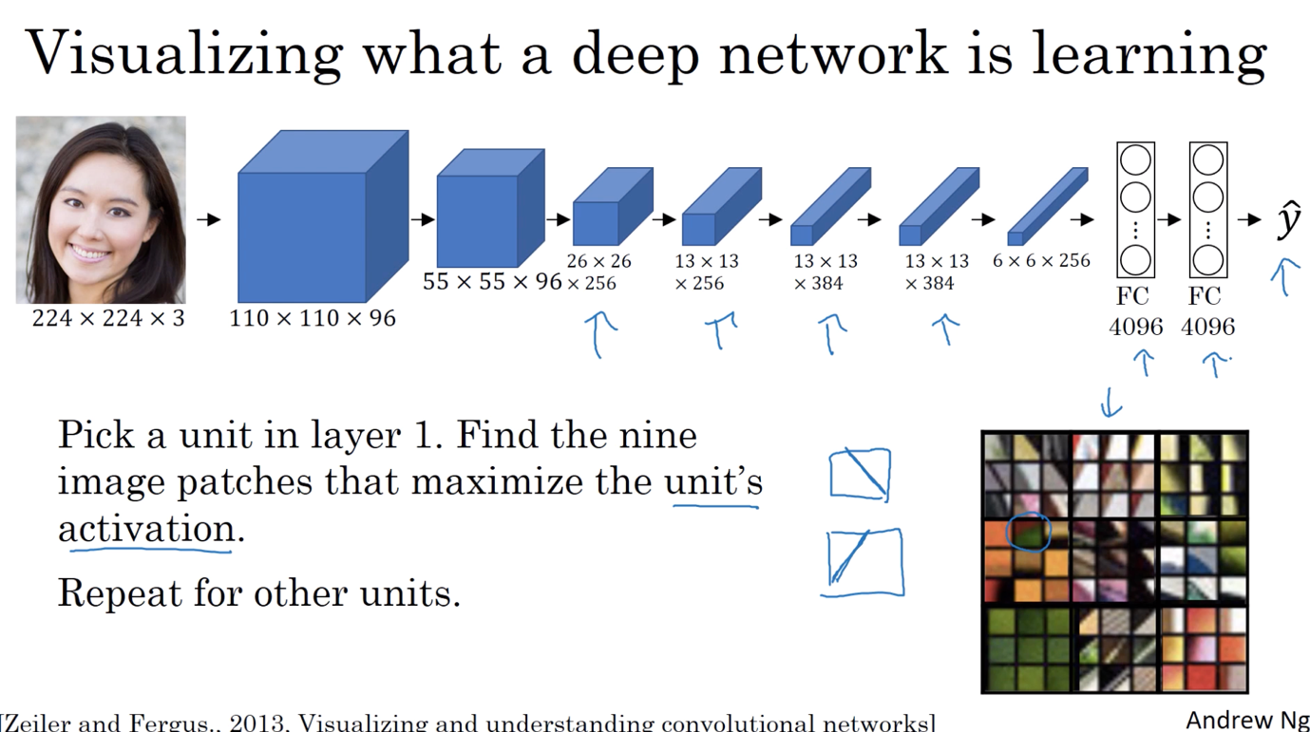

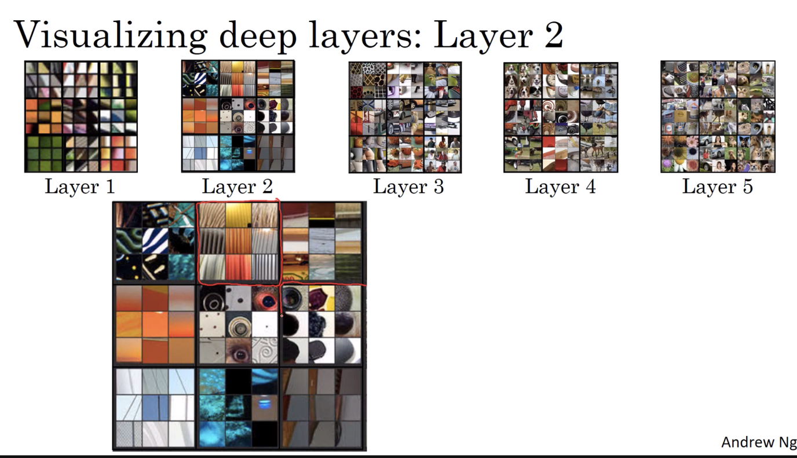

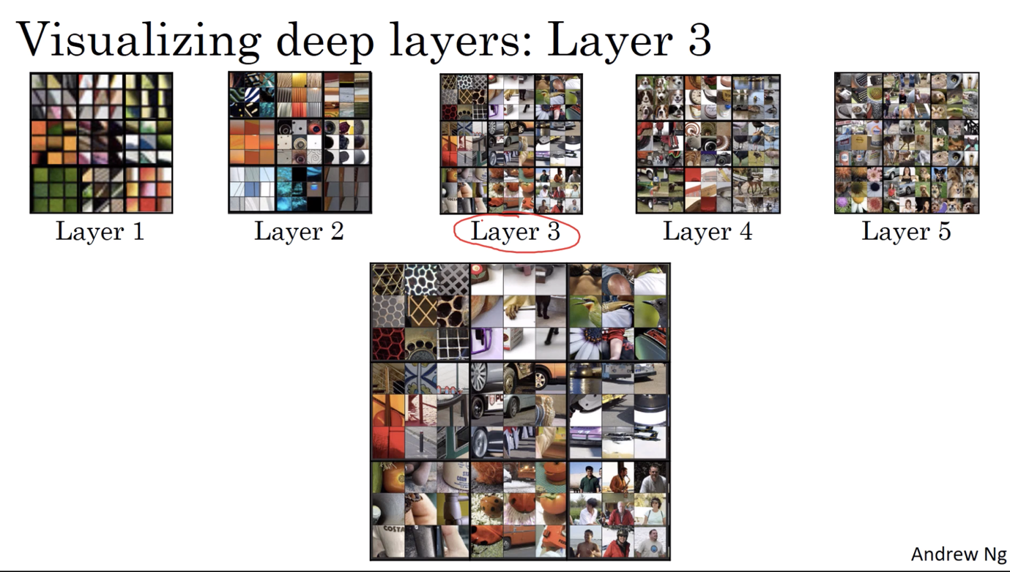

Neural style transfer - Cost function for generative images

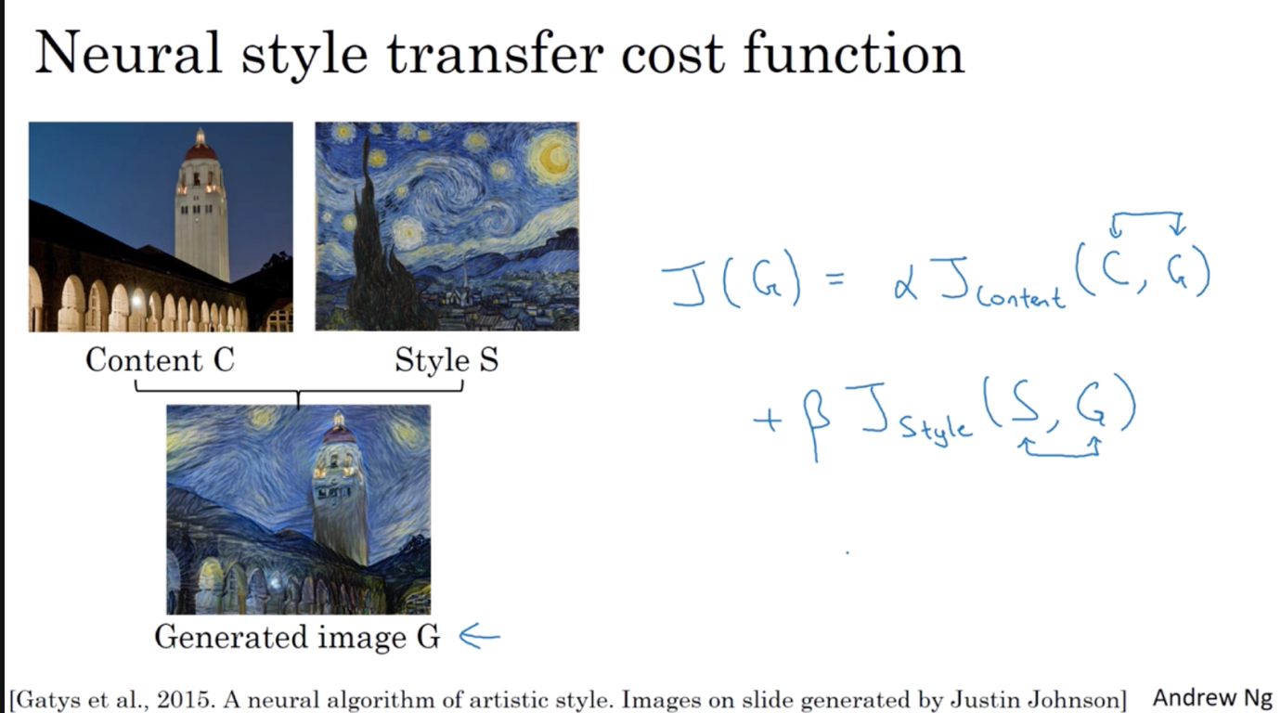

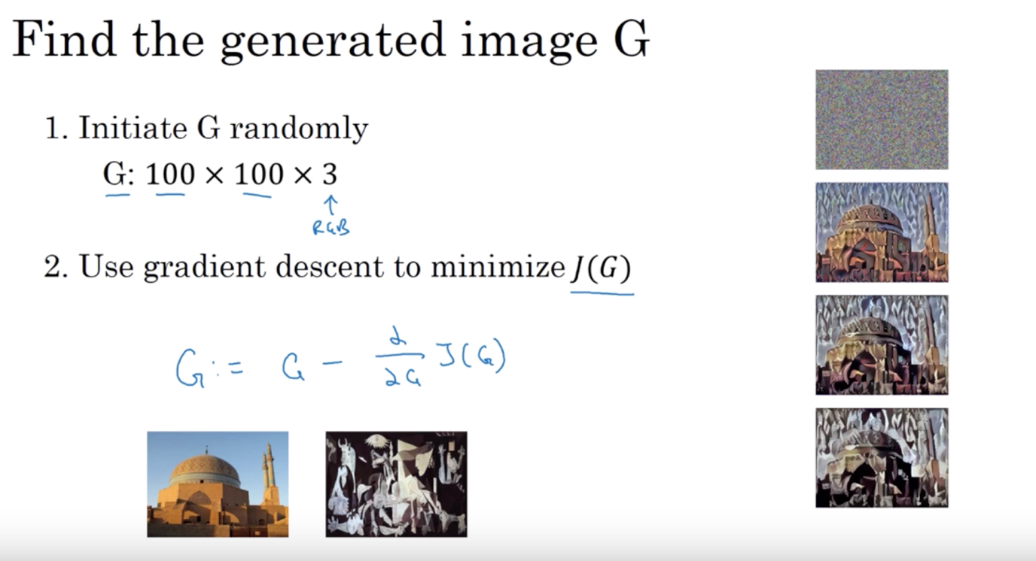

Content cost function

* Overall function of how similar are content and generated image
* So when you do gradient descent to minimize the cost function, you also try to get the generated image to be as close to the content as possible (+ and the style image)

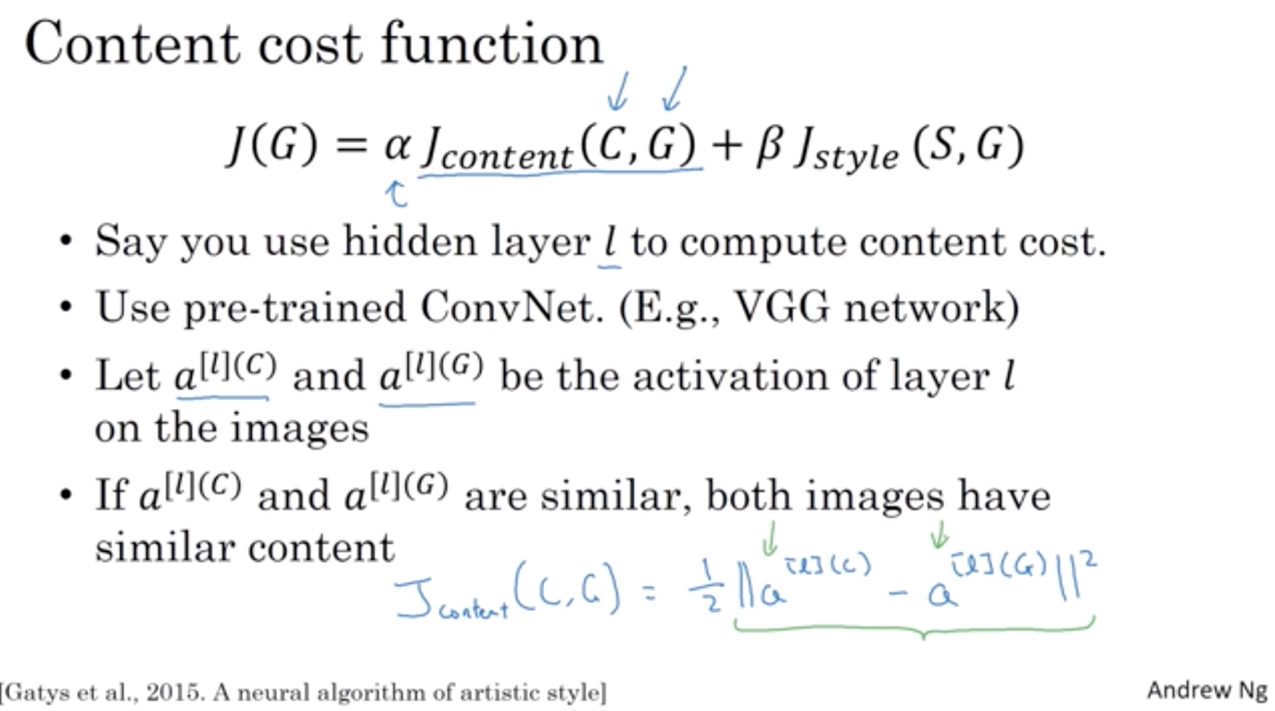

Style cost function

* Correlation tells us if a feature appears, whether or not a different features would also appear => tell us how different features (orange tinge, vertical lines, etc.) appear together or not together or alone
* By using the degree of correlations between channels as a measure of style
* Compute Style matrix

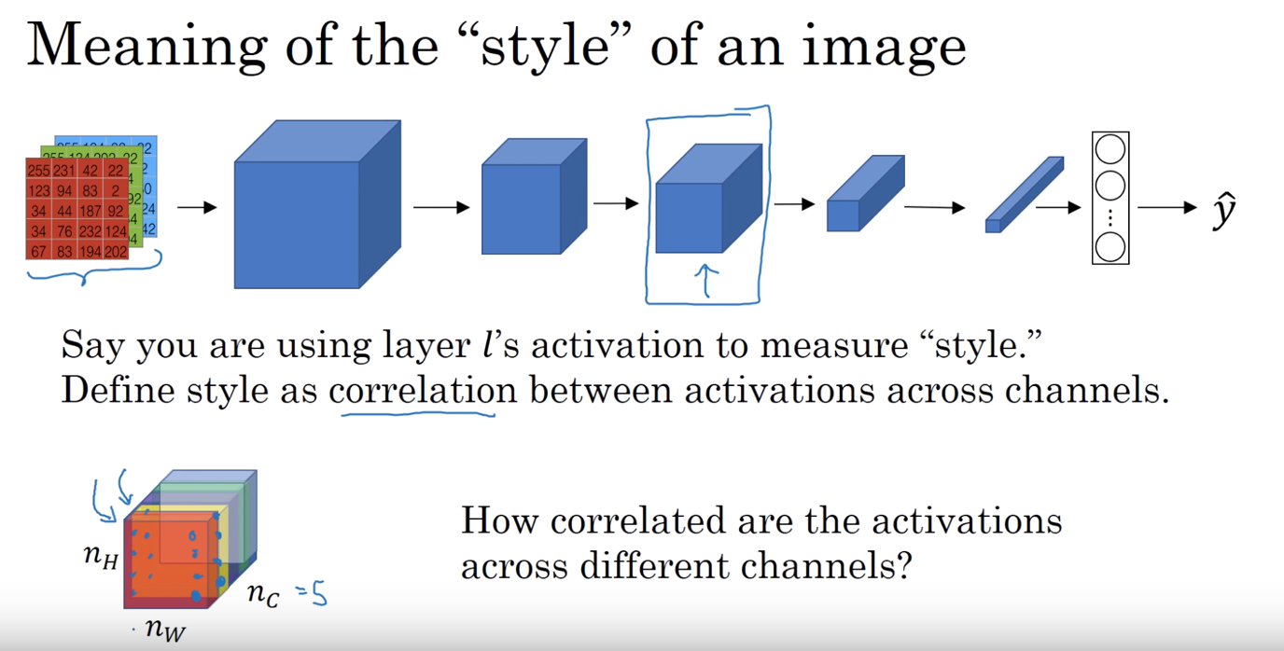

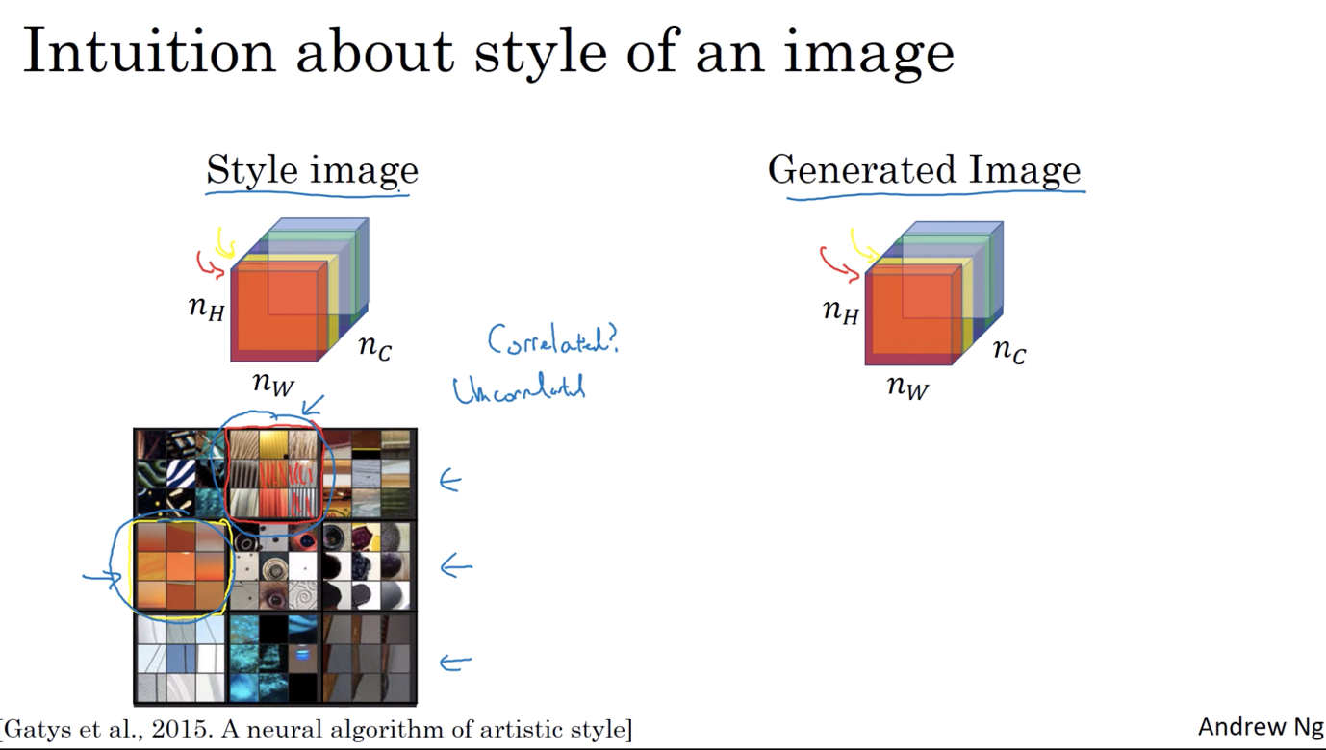

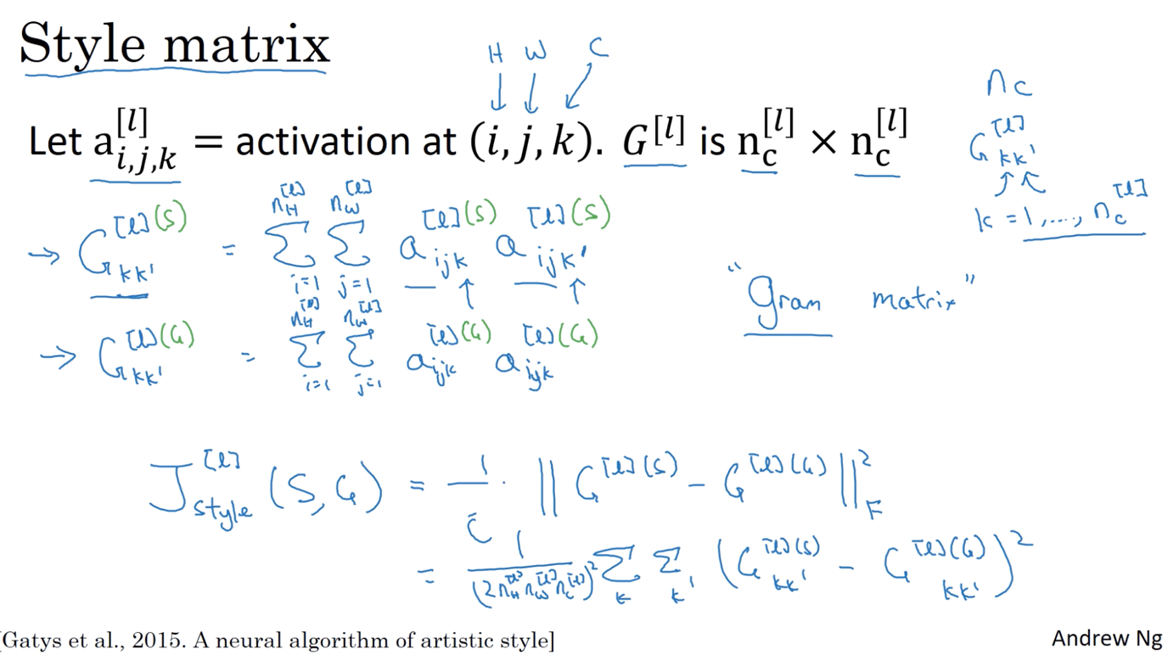

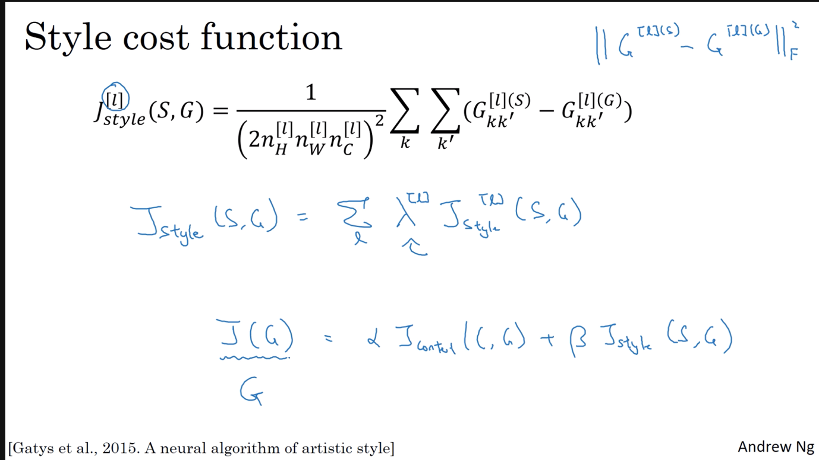

1D and 3D Generalizations

